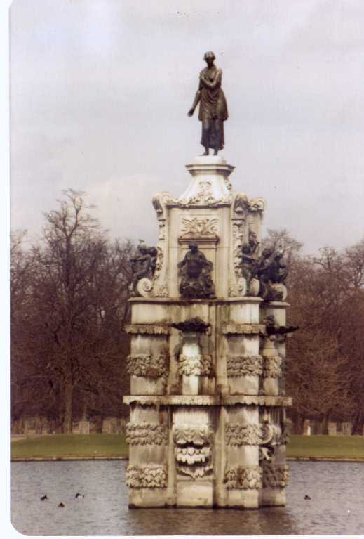

Bushy Tales
Dedicated to all who attended London Central High School at Bushy Park, London England from
1952 to 1962


Issue #1 March 2008 Volume #8
Gary Schroeder (55), Editor gschroeder4@comcast.net
Visit the Bushy Park Web Site at http://www.bushypark.org/

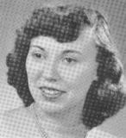
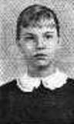
Class Representatives

1953 - Jackie (Brown) Kenny
JKYKNY@aol.com

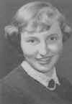
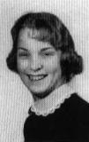
1954 – Betsy (Neff) Cote
betsycote@atlanticbb.net

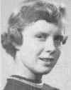
1955 – Nancie (Anderson) Weber
nancieT@verizon.net

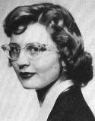

1956 - Glenda (Fuller) Drake
gfdrake@swbell.net

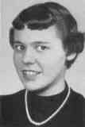
1957 –Shirley (Huff) Dulski
shuffy2@msn.com

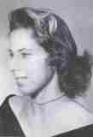
1958 – Pat (Terpening) Owen
CHS1958@sbcglobal.net

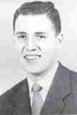
1959 - Jerry Sandham
j_sandham@comcast.net

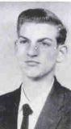

1960 - Ren Briggs
renpat1671@uneedspeed.net

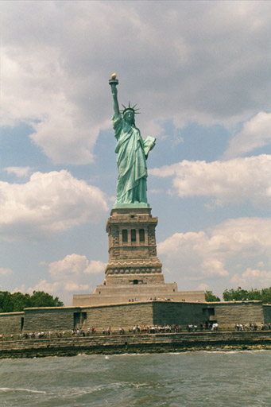

1961 - Betsy (Schley) Slepetz
bslepetz@comcast.net

1962 - Dona (Hale) Ritchie
DonaRitchi@aol.com

_________________________________

Roster Changes

New Email address
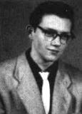
Bob Chilton (58)
bobchilton@verizon.net

New Addresses:

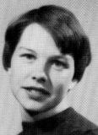
Leola Joy (Sickler) Heslin
11204 East 67th Street
Broken Arrow, OK 74133

_________________________________

Look Who We Found

William Byng Robbins (54)
1703 Melody Circle #311
Port Angeles, WA 98362-4974
NOT INTERESTED

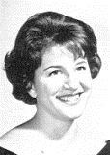
Diane (Steffensen) Pargament (62)
dkparg@starstream.net

She lives in the Sacramento, CA area, and I have her address if anyone wants
to contact her. She'd just prefer that it not be published. - Pat

_____________________________________

Classmates Who Have Transferred To The Eternal Duty Station

Our love and prayers go out to the family and friends of our classmates who have gone on before us. We will miss them, yet we can find comfort in knowing that one-day we will all join them for the greatest of all reunions.

John Devon Markus (58) Received a call from Judy Markus, wife of John, that he'd passed away on February 11, 2008 at Baylor Medical Center in Dallas, TX. John was a retired design engineer with Texas Instruments. He'd served in the US Navy.
Wendell O. Jones, Class President for the Class of 1958 is sending a condolence card from the class.

If anyone would like to send individual condolences, Judith's address is:
7309 Parkview Drive
Bonham, TX 75418-5230

Condolences can also be sent to the funeral home at www.coopersorrells.com.

______________________________________
Reunions

Editors Note: THIS IS PRIMARILY A REUNION FOR CLASSES 1953-1956, HOWEVER OTHER CLASSES ARE WELCOME.

THERE IS A "GATHERING" BEING HELD IN THE DALLAS/FT WORTH AREA FOR CLASSES 1953-1962 ON OCTOBER 10-12. A FEW PEOPLE HAVE INDICATED THEY MIGHT TRY TO ATTEND BOTH.

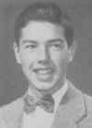
Bob Lyle (54)
Robvlyle@cs.com

Bushy Park Alumni, Classes of
1953 – 1956
Reunion in Nashville, Oct. 5 – 7, 2008

Based on the earlier feedback, there are about 50 of us (including spouses) interested in joining up in Nashville. It looks like we will have an enthusiastic turnout.

Your planning committee, consisting of Gary Baldwin, Billie Bules, Snookie Mayo and me, has
been busy making plans. Included here is information about the reunion and a registration form for the event. We would like to have everyone registered no later than September 2, 2008 but, as indicated below, you may want to act on it much sooner.

The event will be centered at the Guesthouse Inn and Suites in the Music Valley area northeast of downtown Nashville, close to the airport and close to the Grand Ole Opry. To make reservations you should call the Inn at 615 885 4030 and mention
that you are with the Bushy Park High School Reunion Group. The 1-800 number will not work
for our group rate. The cost per night will be $75.00 plus 15.25%. Due to tax increases, the cost has gone up from the $73.00 + 14.25% mentioned in my last mailing. It will be your responsibility to reserve and pay for accommodations.

We reserved a block of 25 rooms. The Inn should be able to accommodate more as necessary but you should make a reservation early to assure your place. For those who would like to arrive early
and/or stay on, these rates are good for our group for the 3 days before and the 3 days after the reunion.

There are 2 official reunion events planned, as follows:

Reception Sunday night, Oct. 5th starting at 6:00 PM with hors d’oeuvres and cash bar

Banquet Monday night, Oct. 6th starting at 6:00 PM with hors d’oeuvres and a cash bar, followed by

dinner and good fellowship.

The cost of these events will be $50.00.

Some additional events have been organized:

Grand Ole Opry: Thanks to Ted Hopkins, we have a block of tickets reserved in the Gold Circle (front center) for the Saturday night performance, Oct 4th at 6:30 PM. From the last mailing we already have a group of 20 people who have reserved and paid for the Grand Ole Opry tickets. Tickets cost $49.00 per person. There are a few
tickets left in the reserved block. We think we can
get more but a second block would not be so well located. According to Ted there are no really bad seats in the house. If you are interested in this event you should act soon.

Lecture: Our very own Ted Hopkins has agreed to give us one of his patented presentations, this one entitled “No One Can Break the Sound Barrier.”
(The nature of sonic booms, commercial flights, a Government Study and humorous stories that happened over Oklahoma City. Why the Concorde never flew across the USA). The presentation will take place Tuesday morning,
October 7th at 9:00 AM at the Guesthouse Inn. All you will have to do is show up.

Luncheon Cruise and Show: We will be boarding the General Jackson Showboat at
11:00 AM on Tuesday to cruise on the Cumberland River, enjoy a buffet lunch and see a show on the world’s largest showboat. We have reserved a block of tickets which will cost $49.12 per person.

Please complete the attached registration form and email it to me, or send it to me by mail with your
check at the indicated address. If you want to go to the Grand Ole Opry and/or sign up for the luncheon cruise, you should send in the completed form and check sooner as opposed to later.

The deadline for registering is September 2, 2008. This will allow us enough time to complete the necessary arrangements with the Inn, the Grand Ole Opry and the General Jackson Showboat.

The Nashville area offers many attractions which can easily be researched on the Internet and I urge you to check it out. Looking forward to seeing everyone in Nashville.

(Editors Note: See last page of this newsletter for the Registration Form.)
_____________________________________

Memories of Bushy
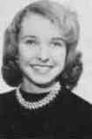
Sherry (Burritt) Konjura (57)
sherger@juno.com

Recently I came across a postcard with the attached picture of the General Alexander M. Patch Naval ship.
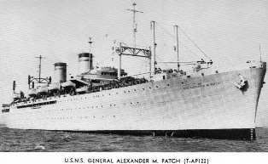

This is the ship that carried my Mother, my little brother, Duane, and me to England from New York in October of 1954. (My Dad had flown to England in May) It sure did bring back a lot of memories. The unpleasant memory is of awaking our first morning at sea and being extremely seasick! Thanks
to the onboard infirmary, I was told it wasn't "fatal" and shouldn't last if I took it easy in the mornings –
sipping Pepsi Cola and nibbling on Saltine crackers. This became my daily "routine" and I was almost always just fine by late morning. The happy memories occurred as I managed to meet some other teens (I was 15 at the time) and we spent our days walking the deck, playing cards, putting puzzles together and enjoying the onboard movies at night after dinner.

My poor brother didn't have such a carefree voyage. He developed a "mysterious" rash. The Dr. thought it was measles at first, but decided that it wasn't measles. Unfortunately, the Dr. never did come up

with an answer for what it actually was. In any case, Duane spent the first several days confined to our cabin, covered in Calamine Lotion. Finally free of the rash, he was able to join us in the common room and proved to be a whiz at Canasta and putting those puzzles together. I don't recall him finding anyone his own age to "pal" with - but he did a good job of keeping up with the teens and adults.
I read with a twinge of sorrow the section "Classmates Who Have Transferred to The Eternal Duty Station" in the latest issue. Both Mahlon and Parke Williams were listed. I didn't know either of them in the short time they spent at Bushy. Their parents decided to send them to school in Scotland before I arrived at Bushy Park. I remember that
their father was a high up official in the London division of Exxon (which was Esso at that time). I was at a party in the spring of my senior year when I met the twins. They were home for their spring break and during that short period of time I dated both of them. Although I met Parke first and was really attracted to him, Mahlon more or less pushed his "younger" brother aside and I ended up spending more time with Mahlon and actually corresponding with him for a time. Ironically, Mahlon died this past year on the date of my birthday. Parke, I note, has been dead for nearly 20 years. A shame.

I also read Mike Moorman's message with great interest. My Dad and Mike's Dad worked together at West Drayton. Although Mike was a year behind me, we were acquainted partly because of our Dads and partly because of his older brother Ed. Ed had
just finished his "Plebe" year at West Point and was home for the summer just before I entered my Senior year at Bushy. The Dads (or maybe it was the Moms) plotted together and arranged a meeting between Ed and me and we did end up dating while
he was in England that summer. We also corresponded throughout the fall, but, in both our cases - distance didn't "make the heart grow fonder" and we went our separate ways.

Even when I read something by someone I didn't even know at Bushy - the memories they share evoke old memories of my own. So, thanks again, Gary for keeping this newsletter going! Thanks to you, Pat for all your great detective work and thanks to Wanda for working on the Website. I'd also like to thank each and every person who takes the time

to send something in, be it a long narrative like Walter Hunts' fascinating "Bicycling Europe on $1.00 A Day" or just a short note - all are great contributions. Hope to see more great "memories" in the next issue.

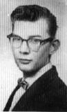
Jim Nichols (59)
sicnis_2000_2000@yahoo.com

Many years ago, before I went to Bushy Park (Central High School), I would go camping with my dad. He was raised in the deserts of Arizona. We would drive the ol' Pontiac until the road ended, grab our gear and hike deep into a sea of hot sand. Here lay a desert,

seldom washed by rain. The cactus were stunted by a enduring thirst. We hiked until the sun reached it's peak. A site was chosen and the heavy loads were dropped. I was handed the small shovel and marched off to build a bathroom. Dad busied himself by putting small sticks in the ground and pebbles on their shadows. He drew a few lines and walked around his dirt diorama. He looked very pleased as we dug our fire place. A quick back rest shelter was erected. A ground cover blanket became our floor. Our house was in order. The fire was started as a small round can was opened. Dad had a fondness for old military rations. The can
was opened and it became a cup, scoop and a frying pan. The big, stale biscuit (inside) was dinner.

Dusk came quickly and we stuffed our pant legs deep into our boots. This kept out the crawlies.

Each of us was past tired and ready for the night.
Before I fell asleep dad would tell me a story of the night time stars. His favorite was Orion (the hunter). He would point out the features and send me to sleep at the same time.

Early in the morning, before sunrise, a gentle hand told me that it was time to wake up. Sunrise was a big thing for him. I believe that it was the main reason we were there.

The black sky was changing to a blue one, then the edge of the horizon could be seen. A orange fire ignited the sky, and the clouds were aflame. The sun came over dad's dirt diagram. My mouth was

open and I was impressed with both mother nature and my dad's strange markings. There, before me, were a compass and a solar clock.

The camp fire was renewed and that little cup was pressed into service. The coffee was bad, but it did it's job. The cup was pressed into my hands and a orange, lumpy mess was in it. I ate quickly and that taste was never forgotten--Powdered Eggs!

The next year as a dorm student at Central High, I found myself (again) eating powered eggs. It was breakfast and I was having a flash back to that camp site meal. I stood and pointed to the offending food with a accusing finger. I spoke very loudly and told the world what I thought of this item. I looked around as a cloak of silence covered the room. I was the center of attraction. I was today's entertainment. I sat quickly. Somebody whispered in my ear that Mister Monroe would like a word with me.

Mister Monroe was the boys' night time dormitory counselor and was giving me a sad face. I kept my head bowed as if in prayer. I knew the drill. I had been in this position before. I was no angel. This time he seemed a bit more alarmed than normal. What he said was not that important but it boiled down to a few words. "Can you tune it down a little and cut the kitchen people a little slack." I nodded my head and went about my day.

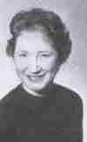
I started to wonder what business it was of his? He was not part of the kitchen staff. He was a night counselor and not on duty for hours. The next day I sat where I could see him and a few of the kitchen people. I watched him and noticed that he would make eye contact with a worker and nod his head. A small nod, but a nod. That worker would go behind a wall and start scrapping dirty plates. I watched as she slipped bits of food from those plates into her pockets.

I knew it! Something was going on and he was involved. He was directing it. The kitchen staff were gleaners. They were taking the scraps home. Those eggs were not meant to be powered. They were mixed with real ones and served. I had exposed their little game with my outburst. I could tell by the hurt look in their eyes. There actions

were a give away too, as I passed the serving line they would drop my food on my hands instead of the plate.

I had to change things. I talked to a few of my friends and they, in turn, talked to their friends. We began by requesting less food on our plates.

I found out that the kitchen would get paid by the number of meals served. We would sometimes go through the serving line twice and get nothing the second time. We showed that more meals were served. The monthly budget was increased. More food was purchased. The kitchen people were perplexed and turned to Mister Monroe. I saw that
small nod again and the next day real eggs appeared. I gave him a little nod.

Mister Monroe had another game he played. Late in the evenings, after the allotted quiet hour, he and his staff, would set up a store and sell candy. The tables would be at the end of long hallways and he did a brisk trade. Every Thursday night I would make my purchases. They would always be four (Zero) candy bars. I would take them with me on the long bus rides every Friday night. One night, as I pushed my monies toward him and he pushed my candy toward me his hand went up as a stop sign and I looked deep into his eyes as he pushed my monies back in my direction. No words were spoken but we talked without them. He said thank
you and I said that he was welcome, all in a quick nod.

Carol (Smith) Benjamin (69)
carolbenjamin@knology.net

I'd like to be able to help you out with a story of my memories--I really would, but the scant memories I have I'm afraid wouldn't be suitable for publication. I've noticed that most of the stories submitted are about trips that people took and I didn't take any trips.

All I remember was in 8th grade I had Mr. Carey and his daughter Meredith was in my class. He had some very high expectations for our class especially for Meredith, so it was an interesting year. I learned a lot about algebra from him. Matter of fact, I

learned all I know about algebra from Mr. Carey, which was only the rudiments, but I got to use that in my later nursing school experience. I'm grateful to him for that.

My fondest memory was playing trumpet in the band and having Mr. Threlkeld for a teacher. He was so enthused about music and he married Miss Hynes, a higher grade English teacher. I went to their wedding in London and it was beautiful--like a fairy tale wedding. Miss Hynes wore a beige lace dress and I thought she was absolutely stunning.

Other than that I remember having Mr. Mitchell for French and the only reason I passed was because I
had such a good accent--think I pulled a D for that accent<BFG> And I remember reading Tale of Two Cities in English--can't remember which grade that was but I fell in love with Charles Dickens right there and then.

I had the most fun with my friend, Alfhild Anda. She was from Norway and lived with a family named Poole<I think> We would sometimes walk to school from Surbiton, going over the bridge in Kingston talking and laughing all the way and it was a long walk, but we loved doing that. Alfhild had the most delightful sense of humor bordering on the ridiculous--I treasured her friendship.

Another friend, Beverly Sallee and I got together on weekends and studied all the different Christian religions to decide what we wanted to be. I chose to become a Catholic and she chose to become a Mormon. Wonder if she'll vote for Mitt Romney <BG> I've lost track of all the friends I had at Bushy Park, but they were all a wonderful part of my life and I feel very blessed to have had them for friends.

But see what i mean? These sketchy memories of mine are hardly publishing material. I'm just sorry I couldn't be more help to you as I do so enjoy reading everybody else's memoirs. Thanks for asking though.

PS I didn't graduate from Bushy--spent my senior year in Mississippi and graduated from S.D. Lee High School in Columbus, Ms.

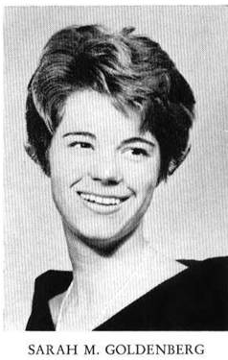
Sally (Goldenberg) Entlich (61) salnrichnfl@yahoo.com

I’d like to add to the Peter Junker stories. I met Peter the year I arrived in England, which was 1959. He was friends with Robin Markel and I met them both at the West Ruislip Teen Club. I dated Robin for a few months and subsequently became pretty good friends with Peter. He especially enjoyed coming to my house so he could teach my father how to play the football pools. I’m not sure what happened to Robin, but I stayed friends with Peter through most of my senior year.

Does anyone remember the New Year’s Eve (1960) party at Peter’s house where we all stayed overnight in sleeping bags on the floor? His folks let us drink something called Babysham, although I’m sure there were lots of other liquid options. There was quite a big snowfall that night and I was able to take a few kids home the next day in my parents’ Hillman station wagon and then continue out to Watford where we lived in the American housing compound. There was a long hill just before turning left into the housing area. I waited, somewhat nervously, at the bottom of the hill for several other cars to make it to the top. A number of parents, including mine, were standing at the top of the hill watching the action. I finally decided it was my turn and got up to speed on the flat stretch, but, alas, some yokel started spinning in front of
me. My father went nuts, of course, and had to bail me out. Not a good day for women’s lib.

Anyway, I have to say that Peter wanted me to go out with him, but I never did, and we didn’t see each other much the last half of senior year. I didn’t keep in touch with him, but did send him a note when I got married in 1965. He sent back a congratulatory telegram. Peter was a good guy.

A quick self bio: From England we went to San Bernardino where the California girls were blonde, tanned, and leggy. Twas not for me—brunette, pasty English white, and short, short, short and I couldn’t get the hang of Valley talk. I spent some time in San Francisco just before Flower Power kicked in, then landed in Fort Campbell, KY, where I met and married my wonderful husband. We spent

26 great years in the Army and stayed in the DC area when he retired from the Army. I was a policy analyst for the Army’s MWR (recreation) program for 20 years. We both quit work in May 2004 and moved to the Gulf coast of Florida. We have five grown children, 10 grandchildren and potentially more to come when our son gets married at the end of this month. We love our sleepy town of Englewood, which is 1½ hours south of Tampa. Every day is Saturday and Life is very, very Good.

_________________________________

This and That
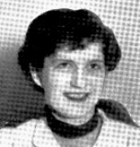
Anne (Jones) Weber (53)
WEBERANNE@msn.com

"A capital ship for an ocean trip was the Whalloping Window Blind"...aka General Rose. I may hold the world record for earliest broken bone on a trans-Atlantic voyage. The ship gave a slight shudder. I slid from one deck to the next, bouncing down the metal steps...while the ship was in New York harbor. Naturally, I waited until the next day to visit sick bay, relying on a small miracle to heal me. The doctor pointed out it would have been infinitely easier to get a clear x-ray in the harbor, rather than the stormy North Atlantic. I got plastered...so to speak...from above the elbow to below the knuckles. "It's only your left hand," said my sister, aka Pollyanna. We were both
to discover soon just how handy that left hand was for cutting meat or buttoning a blouse...a blouse the doctor and I discovered would not fit back over my
cast, and so I spent the trip wearing small sized air force blue pajama tops.

At our first lifeboat drill, a well-meaning crewman said I didn't need to attend any further drills, but then ruined it by adding," "No need. With that heavy thing you'd just sink like a stone."

A bit of humor I failed to appreciate at the time and when on deck watched anxiously for errant icebergs...or great white whales.

The other odd thing I remember about that trip was that I thought for a brief time that I had sustained a brain injury from my fall. Everything tasted of

vanilla. Waffles, pancakes, orange muffins, chocolate brownies, strawberry cake, lemon tarts, even cheese pastries...all had colors that seemed to promise other flavors, but , no, it was all vanilla to me. I thought about visiting the doctor again until my sister complained, "Is the entire menu permeated with the the taste of vanilla?" We never discovered the 'why' for this strangeness but enjoyed making up bizarre story lines to explain the phenomenon.

As I remember, the Rose not only moved up and down with the waves but frequently rolled

sideways. My nephews had a small box of Tootsie Toy cars. They lined them up against the bulkhead at nap time and then watched the tiny racers go back and forth and...whoops...left and right...a sight well calculated to induce shades of mal de mer green in all observers and that, I think, only added to the boys' enjoyment.

A capital ship...which, by the way, we returned on some 3 years later, again the middle of winter, but there were no broken bones, no vanilla extravaganzas. The Tootsie Toys were replaced by Matchbox vehicles that still careened back and forth and...whoops left and right, but we'd been there and done that and nothing much mattered because we were homeward bound.
Pat (Terpening) Owen (58)
chs1958@sbcglobal.net

I got the following message from Mercedes regarding a restaurant they are opening up. Mercedes lives in the Los Gatos, CA area so anyone who lives near there might be interested. She didn't give me the name or location, but if you're interested, just send her an e-mail message. Let's support our Bushy classmates.
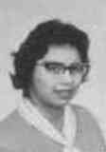
Mercedes (Torres) Dickson-Armentrout (58)
mercedesdicksonM@aol.com

Just a quick note to let all of you know that I'll not be able to attend the gathering in October. We open our restaurant in late spring and

I'll be up to my elbows in the activity. Have a blast. Be sure to post pics. Mercedes
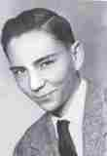
Jerry Kelly (58)
Jkelly1597@aol.com

Brother Mike (Kelly) (60) and family left today to head back to Singapore. His two daughters will fly back from LA but Mike and his wife will go to Hawaii for a week or so and then back to LA and then the long hop to Singapore. Mike has been there since 1992 and this is the second time that he has lived there. Since he was only a 9th grader at Bushy Park he doesn't feel much of an attachment to the school. When the

family came back to the states in 1959 Dad was stationed at Beale AFB north of Sacramento California and Mike went to Wheatland High that was near to the base and he did attend one reunion there. Mike will most likely work for another two or three years but has no plans to move back to the States.
__________________________

The Story Continues
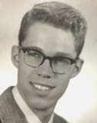
Walter E. Hunt (56)
walt@lobo.net

BICYCLING EUROPE ON $1.00 A DAY:

A Cold War Geographic and Cultural Memoir
--------------------------------------------------------
Chapter 11 - July, Sweden

I left the outskirts of Helsingborg, and started the 500+ kilometer (300 miles) trek to Stockholm. It took two days of steady cycling to reach Joenkoeping, another two days to Norrkoeping, and two more to reach Stockholm. I was two weeks into my trip.

The smells along the way were wonderful—mostly newly mown fields of hay, along with the fragrance of dairy farms. Traveling by automobile or

motorcycle is not the same. I cycled at an average speed of about 10 miles per hour, slow enough to observe everything, and smell everything. The road to Stockholm was perfect for a cyclist—smooth, and wide.

At the beginning of some of the small towns was a sign with the name of the town or village, and what I thought was the number of barns in the village. I thought it was quaint, until I learned that "bairn" in Swedish translated to "child." I never learned if this
was the true translation, or if this was, in fact, a sign that gave the population for the village.

I found a small farm that had a barn just outside Stockholm, a few miles off the main highway, in
Stureby. When I asked if they had some hay I could sleep on, I used the universal sign language I had learned—grabbing some weeds and grass, and putting them to my head. They indicated they were not a working farm, and had no hay, but they did have an extra bedroom I could stay in for no charge. I was thrilled. I told them I wanted to see Stockholm and asked if I could stay with them for a couple of days. That was fine with them. They had a 12-year old son and asked if, in exchange, I would speak some English with him every day. The next day they gave me a list of places to see in town. This family introduced me to knäckebröd, the large, round, crisp, rye crackers that became a favorite, and have kept many events of this trip in my memory over the years. I maintained a correspondence with this family for several years afterwards.

I went to see the Youth Hostel in downtown Stockholm, which was an old sailing schooner, and the only way to get a berth there was to have reserved it months ahead of time. It was a splendid hip and I thought it would be worth coming back to.

Because the winter climate was severe, many of the roads in Sweden were unpaved, but nonetheless smooth. However, by the time I got to Stockholm my speedy street tires had been patched a number of times from collisions with rocks. At a local bike shop, I bought a pair of heavy-duty knobbies. This type tire was common in Scandinavia, but I had never seen any on the Continent. (They were still on my bike 16 years later when it was stolen.)

Overall, the roads in Sweden were ideal for biking. They were largely paved and smooth, and most of all, flat—at least on the way to Stockholm.

I started to the West, towards Norway. The main highway was unpaved, and I wound my way towards the mountains. I could see from the maps that I was in for an uphill climb that might last a week. After 3 days of hard cycling I arrived at Karlstad. Oslo was not much further. Another two days and I crossed into Norway. It was only a short distance to Oslo.

________________________________



Leola Joy (Sickler) Heslin (55)
l-j-hwh2736@hotmail.com

Thanks for sending the up date. I was able to read them. Wish I was better on the computer. I know I should take a class but I just don't seem to have the time. Where does it go? I remember I had time to do my house work when I had five little boys running around the house but now that it is just me and my husband I don't even get that done.
While I am taking the time to write this afternoon I need to let you know that we are moving again.
I know this seems like old news but it is new to us.
We didn't plan a move for a long time. We like Las Vegas and our apartment. But things happen, or at least they do to us.
My oldest son who lives in Tulsa, OK has asked us to move into this rental home in Broken Arrow, OK. It took a lot of prayers and meditating but we saw the light. He said he wants us to care for the home rent free as long as we want to stay. He added that he would take care of Ward and me if we needed anything. I am so proud of all my boys and have always believed in them. This has just proved I was right.
It is going to be different for us. We haven't ever lived so close to any of our 13 children. There will

be 9 of the children no more the 6 hours away. I hope that doesn't mean we will have company all the time. I wouldn't mind seeing them and our grandchildren. That in itself will be different and fun. We have 42 grandchildren and about half will be living near by.
Our new address will be, 11204 East 67th Street, Broken Arrow, OK 74133. Our cell phone number will not change, it is: 1-801-398-3831. Yes it is a Utah number.
Thanks for doing all the work you do with the news letters.

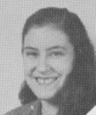
Jane (Berryman) Murray (56)
Murray-Jane@aramark.com

Hi, Gary I wasn't sure about your instructions. However, Judith Berryman, Joe Berryman, Jay Berryman and my self are planning to attend the reunion God willing. The picture of Joe Berryman in the newsLetter is really Jay. He Lives in NZ and his e-mail is judyb@top.net.nz Your newsletter was great and stirred up a lot of memories. I recall going to London one Saturday and sitting at #10 Downing Street waiting to catch a glimpse of the great man who was one of my childhood hero's (Winston Churchill) and Roy Rogers of course.

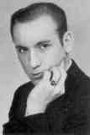
Aaron (Pete) Peters (57)
aaronosb@hotmail.com

Hi Folks,
Just finished talking to Shirley. (Shirley
Huff Dulski 57) She is doing well. Is now walking with the use of a walker and is doing therapy 2x daily. So if you call and there's no answer that’s where she is. She will see her doctor on Feb 14th
and perhaps will be able to go home then. But let us underscore the perhaps.
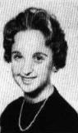
Lydia (Ropp) Crewdson (62)
lydiacrewdson@yahoo.com

Gary,
So glad about your daughter's recovery.

My husband and I are in rehearsal for the play "Damn Yankees". Imagine this ole lady being a 20 year old wife. Last year I played a 10year old little girl. I guess I am continuing what I started back in Bushy.... Being a ham.
Biddie

Laurie Hindley
aurie_hindley@asl.org

My name is Laurie Hindley and I am the Director of Alumni relations at the American School in London. Jerry Sandham, an alumnus of the American School in London, passed along your newsletter, Bushy Tales. What a wonderful publication! It is my understanding that LCHS and ASL may share some alumni. Would it be possible

to include the following paragraph and Reunion logo in an upcoming issue of Bushy Tales?
"Did you attend the American School in London? Would you like to reconnect with fellow alumni? Please send an email to alumni@asl.org with your name, years you attended ASL, and any other details you care to share: the names of your teachers, memories, and updates. ASL is hosting an All-School Reunion in May. We hope you can join us! Visit www.asl.org/alumni for more information."

23-25 May 2008
Cheers, Gary!
Laurie
Laurie Hindley
Associate Director of Development for Alumni Relations
The American School in London
One Waverley Place

London NW8 0NP
+44 (0)20 7449 1409 direct phone
+44 (0)20 7449 1355 fax
www.asl.org/alumni

_______________________________

Now for one of those fillers you have all grown to love. ☺

An elderly couple were on a cruise and it was really stormy. They were standing on the back of the boat watching the moon, when a wave came up and washed the old woman overboard. They searched for days and couldn't find her, so the captain sent the old man back to shore with the promise that he would notify him as soon as they found something. Three weeks went by and finally the old man got a fax from the boat. It read: 'Sir, sorry to inform you, we found your wife dead at the bottom of the ocean. We hauled her up to the deck and attached to her butt was an oyster and in it was a pearl worth $50,000 .... please advise.'
The old man faxed back: 'Send me the pearl and re-bait the trap.'

BUSHY PARK REUNION – NASHVILLE, TN.
OCTOBER 5 – 7, 2008
GUESTHOUSE INN & SUITES
2420 Music Valley Drive
Nashville, TN 37214
Tel. 615 885 4030

REGISTRATION FORM

Name _________________________ Spouse or Guest ____________________

Address _______________________________________________________________
Telephone Number _______________________
Email Address ___________________________

Class of _________
EVENTS

Reception – Sunday, Oct. 5 – 6:00 P.M Banquet – Monday, Oct. 6 – 6:00 P.M.

Cost per person for both events $50.00 # attending ____ Total $_____________

OPTIONAL EVENTS
#1 #2
Grand Ole Opry – Sat. Oct. 4- 6:30 P.M. Luncheon/Cruise – General Jackson
(If you have not already reserved for this Showboat – Tues. Oct. 7 – 11:00 A.M.
event, there are seats available & cost will Cost per person $49.12
be $49.00 per person.
# attending_______ Total $________ # attending______ Total $_________

GRAND TOTAL DUE $___________

PLEASE MAKE CHECKS PAYABLE TO:
Robert V. Lyle
109 Hop Brook Road
Simsbury, CT 06070
Telephone: 860 651 0852 Email: Robvlyle@cs.com

DEADLINE FOR REGISTRATION IS SEPTEMBER 2, 2008

Note: The Reception and Banquet will be held at the Guesthouse Inn & Suites.

Volunteers will be needed for such things as registration desk, memorabilia table, name tags, etc. I am willing to volunteer in the following way ______________ .

