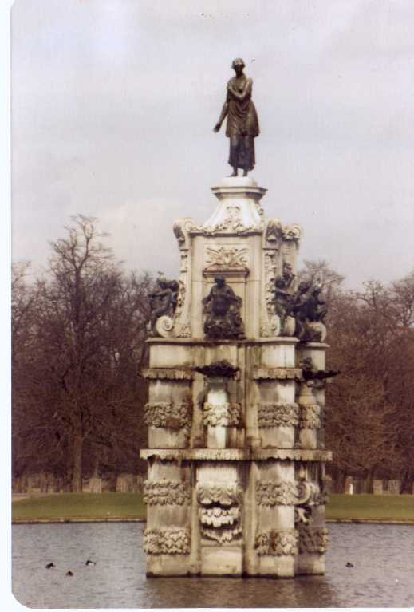

Bushy Tales
Dedicated to all who attended London Central High School at Bushy Park, London England from
1952 to 1962


Issue #10 December 2008 Volume #8
Gary Schroeder (55), Editor gschroeder4@comcast.net
Visit the Bushy Park Web Site at http://www.bushypark.org/

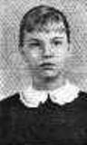
Class Representatives
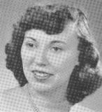
1953 - Jackie (Brown) Kenny
JKYKNY@aol.com
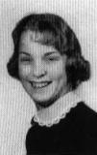
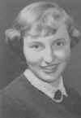
1954 – Betsy (Neff) Cote
betsycote@atlanticbb.net

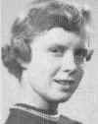
1955 – Nancie (Anderson) Weber
nancieT@verizon.net

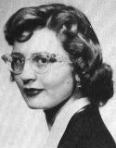

1956 - Glenda (Fuller) Drake
gfdrake@swbell.net

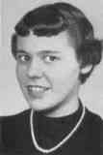
1957 –Shirley (Huff) Dulski
shuffy2@msn.com
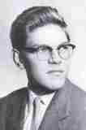

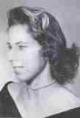
1958 – Pat (Terpening) Owen
CHS1958@sbcglobal.net

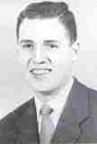
1959 - Jerry Sandham
j_sandham@comcast.net

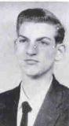

1960 - Ren Briggs
renpat1671@uneedspeed.net

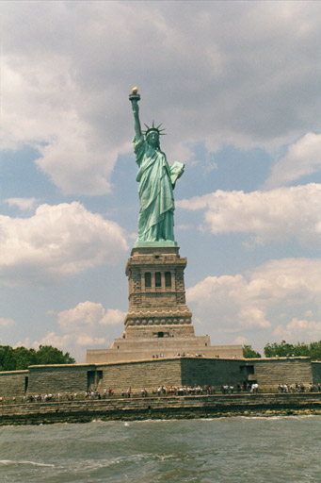

1961 - Betsy (Schley) Slepetz
bslepetz@comcast.net

1962 - Dona (Hale) Ritchie
DonaRitchi@aol.com

_________________________________

Roster Changes

New Email address:
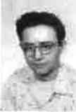
Dennis K. Linsley (58)
dklinsley@comcast.net

Malcolm Osmundson (58)
malcolmosmundson@btinternet.com

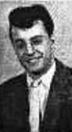
William “Bill” Percy (59)
billpercy@ymail.com

______________________________


Reunion
Information

(Editors Note: The following articles and pictures are ones that I could not get into the “Special Issue” I sent out earlier this month. I also received more pictures than I could put in with the articles so I am going to make the last couple of pages of this issue just pictures from the two reunions. Wish I had more pictures from the Nashville reunion.)

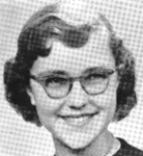
Mariann (Walton) McCornack (53)
MGM@wideopenwest.com

Dear Gary,
I was sorry you could not be at the reunion in Nashville, but here are a few of my photos if you want to use them. I think it is pretty amazing that after all these years all four of us that were roommates in 1953 were able to be at the reunion. It is the first time Lois and Susie joined Betsy and me. We all wonder what happened to Bobbie Brewer . Does anyone know how to contact her? I also want to thank the planners of the Nashville reunion. The seats for the Grand ole Oprey and the Chinese Acrobats on the Riverboat cruise were both front and center-couldn't be any better.

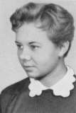
Carol (Albert) Yacovone (57)
CYaco149@aol.com

Ok so my husband Phillip and I made it all the way out to Texas via some really nice side trips for the reunion. We traveled there by RV and got set up at camp site day before the reunion started.

Picked up Robyn Rudat Allen at the airport on Friday and joined up with Bev Gehrett Wagner at the hotel. It was great that they could room together, Robyn had not seen Bev since the Houston reunion in 88. I am more fortunate in that Bev visits here from time to time because her sister lives near us and of course Robyn and I are sisters at heart and have remained best friends all these years.

Special treat for all of us to see Joyce Knapp at this reunion. We had not seen her since Bushy Park days. Also first time to join a CHS reunion was Mike Hall class of 59. They did a great job even though this was a small group and the hotel was very nice. Bev, Robyn, Sandi Scanlon and I were escorted all over town by my charming husband Phillip. We enjoyed visits to the Stock Yard and Billie Bobs along with a wonderful luncheon and dinner with the whole group from CHS.

Some pictures attached for your use if desired. Sorry about the quality, we failed to take our digital and had to rely on old trusty 35 mil.

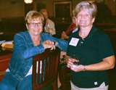

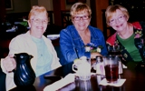
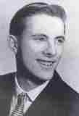
Mike Murphy (58)
oldsalt1223@aol.com

Well, from my prospective, the reunion was great. The class of 1958 had their 50th class reunion. There were 22 members there. We had a special dinner for the 58 class and their spouses, friends and others. It went very well. Oren Jones planned it out and he did a great job. A special thanks to Pat Terpening Owen for her hard work.

Some special memento's were handed out, including t shirts and mouse pads for the 58 group. The mouse pad had the CHS logo on them and class of 1958 with a blue back ground. Ren Briggs, class of 60 managed the whole affair. It was held at the DFW airport Marriot. Since there were no distractions such as casino's and outside interference, we were able to just sit and talk, bring up old memories and renew friendships. The event was highlighted by a dinner banquet on Sunday. Doss Harsch's son had part of his band there to play. Gifts were raffled off and everyone had a great time. Judy Risler Covington brought her book about
Bushy Park with her and was able to sell around 20 copies.
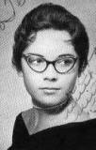
Judy (Risler) Covington (60)
lchs1960@aol.com

I have written a small book about Bushy Park, and some of my experiences therein, plus some pictures of those people and places near and dear to me, and would like to know if any of you would like a copy. The cost is $15.00. If you have any questions, contact me and I will tell you all about it.

My address is: Judy Risler Covington, 114 Oliece Drive, West Monroe, La. 71292. Or you can call me at 318-388-1576.

Aside from that, just wanted to report we had a wonderful time at the 2008 Gathering in Fort Worth/Dallas. It was a very laid back type of get together. We mostly just sat around and did a lot of catching up and reminiscing. It's amazing how charged up you get thinking about seeing each other again, and then when you get to where you're going, there are so many other things cooking that keeps you from doing what you went there to do: reune!

Over the weekend, a few did venture over into downtown Fort Worth, to the Stockyards, to witness a bit of the old west and shop some, but that was about the extent of our extracurricular activities as a whole. Most preferred to just schmooze around in the beautiful hotel lobby, or at the uncrowded bar adjacent to it, and enjoy getting back together. It's always amazing to me how, after all the time that's passed between, we can just pick up where we left off a year, or decades before, and keep right on ticking. To be able to do that so effortlessly has to be an ingrained trait in all of us.

In honor of their 50th reunion, the 1958 Class had a sit down dinner Saturday night at a very nice eating establishment, Class President Oren Jones presiding, and about thirty-five in attendance. The restaurant was colorful, the service excellent, the food delicious, and the conversation lively. A memorable occasion for all the '58 grads, as well as for those of us just along for the ride.

But for the rest of the weekend, we all just kind of schmoozed around and enjoyed each other's company. Pure bliss to yours truly. I always feel like I've come home whenever I'm around any of my Bushy Park buds.

So, be sure and let me know if you'd like a copy of my "literary" effort. I really think you'll enjoy it.

_____________________________________
Mini
Reunions

Bill Rees (57) (no picture available)
brees01@comcast.net

Mini reunion in Minneapolis with Shirley, Carolyn and myself. I was there attending the University of Michigan, Minnesota football game won by Michigan 29-6. We got together for dinner and had a wonderful time reminiscing. Lots of water over the dam since the class of 57 graduated. It was a blast talking about old times. It gave us a chance to catch up on all those years. Pat Owen urged me the send this to you. As you know we all look forward to your monthly newsletters.

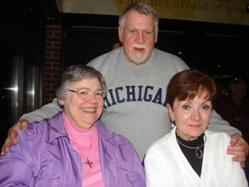

___________________________________
Memories of Bushy

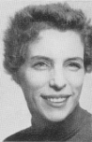
Martha Gail Kelly (57-86) (Faculty)
martha.kelly@virgin.net

Hello, Connie - I thought you would like to know that many of the faculty, old and new, agree with you; you were 'a pretty good group of kids because we sure turned out to be an outstanding group of adults!'
I am so glad Frank Janusz was there so he could re-assure you all of the pride those of us still in touch take in our students - that includes 'kids' from the 50s, 60s, 70s and 80s. There are Bobcats in every field of endeavour throughout the US. Long may your special connection continue. You enjoyed a

special experience. I was especially impressed with the four roommates from 1953 - that's unique!
Best to you and your classmates.

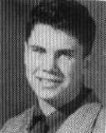
Peter Burnett (58)
peterb40@sbcglobal.net

CHAPTER I

Once upon a time, and in a land far away in time and yet it was but yesterday.

Tech Sergeant Burnett came home to our little cottage in Canyon Crest, near Riverside and March AFB, ---- “OK, listen up, we are moving to England.” Of course, the world turned up side down, I was finishing the sixth grade, and “in love” (the start of many to come). Dad was a GCA/Tower Supervisor and we were leaving the known civilized world for some place called “Upper Heyford”. He departed the ZI in January and our
family was to follow. Mother was sure that England would have new adventures. Besides, steak had risen to $.89 a pound and gasoline was headed towards $.25 a gallon.

The adventure began in torpedo like 49 Oldsmobile sedan through Arizona, where I, thinking it was soup, started to eat the chili salsa sauce with a spoon! This was a “class car” with a brown canvas evaporating water container in front of the radiator and a swamp cooler blowing wet air in my ear on the passenger side door. As I remember, it was October or November of 1951. Many adventures were to follow before we made land several months later in England.

I had made my escape! Having fallen into the bad company of and misdeeds of “older boys,” I had made history ---- the youngest juvenile ever placed on formal probation in Riverside County for my fast living. OMG, 11 years old and my very own PO (that’s Probation Officer for you the unwashed)! I make restitution of $46 and was strongly advised to seek other company. I was tired of those weekly reports to the PO and I was ready for a change. Besides, he got grumpy sometimes!

Winter in Holyoke Massachusetts prepped me for years to come in England. Our wait was tempered

by a to month trip home to my family in Bermuda where I had been born and raised before mom and dad were married before our move to California. However, that is another story unto itself. Sergeant Burnett was a kind man, and many times in my youth, I had failed to appreciate that fact. It takes a big heart to accept a package deal that includes a fiancée with an eight year old child! He never used the “step” term ever. We were a family and I was formally adopted in Newmarket, England in British courts.

King George VI passed away while we were home, and I was becoming anxious to get to England and help out the government!

It has become March, 1952 and we are at Westover AFB awaiting shots and transport orders for a flight to England. I missed out on the week at sea you all revel about. Mother was sis months pregnant with my second sister, Mary. And, I was carrying my firs sister, Sandy, during all our travels.

Finally, after what seemed an eternity, a Navy C54 was designated to carry us across “the pond,” and we were on our way. A few hours out, the plane turned very cold and out came masses of USN blankets. We planes heating system had failed ad we made an unscheduled overnight stop in the Azores. Carrying my sister, her head dangling over my left arm, I somehow managed to smack her head into the door jam. Half way to the plane’s ramp, she woke up---- if looks could kill! Two hours out of Azores, the heater again failed and out came those USN blankets again. We eventually landed at Burtonwood without further event. I has enjoyed practicing my limited Portuguese in the Azores ----- a few bad phrases including ‘kiss my a-- ‘Yeh, I was a smart ass kid!

We made land at RAF Burtonwood, somewhere in mid-England. I saw an Englishman, my God, they looked just like us! It does appear however that we are to remain divided by a common language! We were reunited with dad and soon on our way to Upper Heyford and Oxford.

What, no hamburgers!? I scanned the menu from top to bottom and back again ---- not a hamburger in sight. I ordered a fried egg sandwich on toast.

“So sorry sir, fried eggs are off at half noon. It is time for poached eggs now.” OMG, their eggs, if not their hens, tell time! Did they really found our country?

We would our way through the beautiful English countryside but its beauty is almost lost on this weary eleven year old boy. Too far from the base, I was placed in an English school in Summertown, an Oxford suburb. Classes weren’t too much different, but my hands were always sore. Caning was a new experience! Also, the boys and girls playgrounds were separate, and I had an epiphany; I wanted to play with the girls. I met Bob Short while in Summertown (LCHS 54).

Our last picture had been hung, and a move to Lakenheath was ordered. Lakenheath Jr. High and the eighth grade was a wonderful, educational and true growth experience. Joe Russo was our eighth grade teacher. He had been a DOD teacher in Japan from 51-53 and he saw that we received a comprehensive learning experience. Mr. Russo is one of my top-five ever teachers!

September of 54 found me waiting for a motor coach outside the Newmarket Plunge every Sunday in the late afternoon ---- it was time to be a “dormie” and for the Bushy Park Experience!

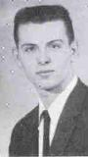
Robert Harrold (60)
rharrold@harrold.org

Bill Percy graduated in 1959, one year before '60 when his brother Bob (John) and I graduated.

Bill & Bob returned to the states early in '59 to Bunker Hill AFB in Indiana and in Aug of '59 my folks transferred there too. Our houses were about 2 or 3 apart. Bill, Bob and I hung around a bit during '60 until Bob (John) Percy and I graduated.

My folks transferred to Barksdale AFB in Shreveport/Bossier, Louisiana and I joined the AF that same August '60. I met Bob'n Bill off and on until around '64 when I got out of the service and went to college in Ruston, La at La.Tech. Didn't see Bob and Bill again 'till the 1st Vegas get-together.

While station in AF in '60-'63 down in Lake Charles at the old Chennault AFB I used to drive up to
Shreveport/Bossier and visit with my folks and hang around with Jerry Reisinger which I did even through college at nearby Ruston through the late '70s 'till Jerry left Shreveport.

Missed communicating with Jerry after that. Was saddened to hear that he'd died around the time of Vegas get-together. I did get to meet Pat Guidry, a girl from Bushy Park who lived in Lake Charles, La. She and I were friends for a while. She was studying Opera Singing at McNeese State there in Lake Charles. She got married some time around '62 and lost contact with her.
___________________________________
This and That

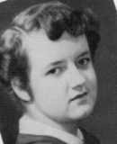
Gemma (Gamble) Rettmann (54)
darett@comcast.net

Thanks for using my reunion write up, we did have a good time, and missed you! You have had quite a year! Sam Myers suggested a book we would be interested in, Military Brats by Mary Edwards Wertsch. (Legacies of childhood inside the fortress). I got it from the library and am reading it, I think a lot of the group would really enjoy reading it if they haven't. Enjoy isn't quite the right word, but anyway, it's very enlightening. Thought you could put a note about it in the next newsletter. Stay well, and have a good Thanksgiving.
____________________________________

