- 1 -

Bushy Tales
Dedicated to all who attended London Central High School in Bushy Park, London England from
1952 to 1962
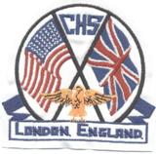
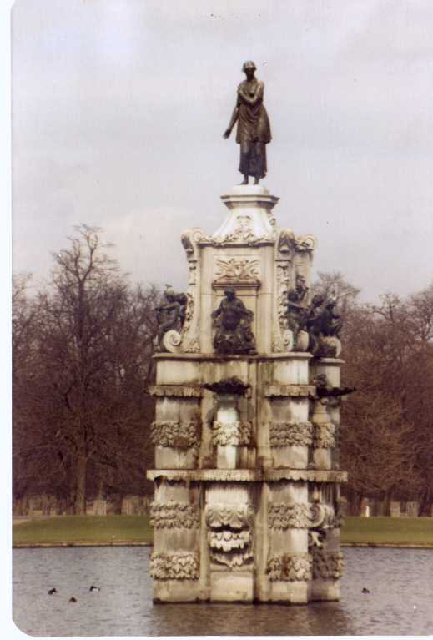

Issue #3 May 2007 Volume #7
Gary Schroeder (55), Editor gschroeder4@houston.rr.com
Visit the Bushy Park Web Site at http://www.bushypark.org/

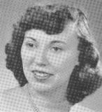
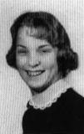
Class Representatives

1953 - Jackie (Brown) Kenny
JKYKNY@aol.com

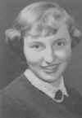
1954 – Betsy (Neff) Cote
betsycote@atlanticbb.net

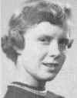
1955 – Nancie (Anderson) Weber
nancieT@verizon.net

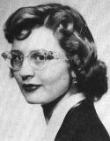
1956 - Glenda (Fuller) Drake
gfdrake@swbell.net

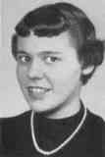
1957 –Shirley (Huff) Dulski
shuffy2@msn.com

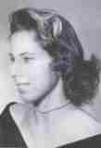
1958 – Pat (Terpening) Owen
CHS1958@sbcglobal.net

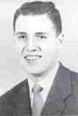
1959 - Jerry Sandham
j_sandham@comcast.net

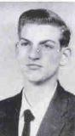
1960 - Ren Briggs
renpat1671@uneedspeed.net

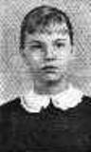
1961 - Betsy (Schley) Slepetz
bslepetz@comcast.net
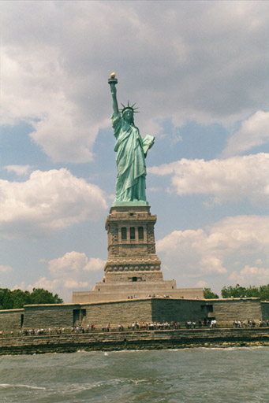

1962 - Dona (Hale) Ritchie
DonaRitchi@aol.com

Roster Changes

New Email address:

John Enroth (56)
johnemenroth@msn.com

New address:

Joy Sickler Heslin (55)
3055 S. Nellis Blvd. # 1033
Las Vegas, NV 89121
Home PH.# 1-702-982-2049
George Bishop (60)
809 Memory Lane
Southport, N.C. 28461

New Email and address change.

William (Bill) Rumble (57)
gfgcamarillo@verizon.net
4977 Via Fresco
Camarillo, CA 93012-4039
Home Tel: 805-388-1263
Cell: 805-302-2017

Harry Bacheler (57)
hbacheler@aol.com
2205 Missouri Ave
St. Cloud, FL 34769
(407) 957-9144

Look Who We Found

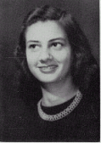
Rosa Therese "Buddy" Arns (54)
RosaP1935@peoplepc.com
7318 E. Highway 37
Tuttle, OK 73089
H (405) 387-3658 C (405) 249-1377

Virginia "Jean" Beard Pitt (54)
jeanniepitt@comcast.net
321 Shoreline Road
Lake Barrington, IL 60010
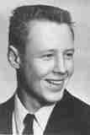

Willard "Bill" Wolfe (58)
1105 E. Main Street
Austin, AR 72007

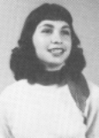
Connie Beard Ruppert (59)
299 Old Mill Road
Dover, DE 19901

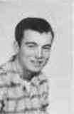
Robert L. Seabolt (59)
11953 Madrona Street
San Antonio, TX 78245

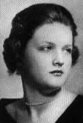
Rita (Manning) Blauvelt (60)
Ritablauvelt@aol.com

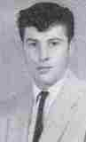
I got this site from my sister, Patricia. I was in the class of 1960. Rita Manning, now Blauvelt. I married SSGT Edward Blauvelt at Woodbridge RAF base in Dec. 1960 in the base chapel.I now live in Hudson, Maine. Patricia lives in Georgia. I enjoyed reading the newsletters. I've only kept in touch with a few classmates, most I lost touch with during moves.

Norman D. McCord (60)
normanmccord@comcast.net
3735 Viola Drive
North Highlands, CA 95660

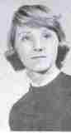
Jacklyn (Woolman) Stebler (60)
Geneva, Switzerland

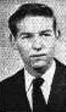
Ronald W. Brooks (61)
chesterpain@yahoo.com
544 Countryside Lane
Chico, CA 95973

Patricia Manning Nobles (62)
bwnpln@charter.net
6512 Ivy Springs Drive
Flowery Branch, GA 30542

Classmates Who Have Transferred To The Eternal Duty Station

Our love and prayers go out to the family and friends of our classmates who have gone on before us. We will miss them, yet we can find comfort in knowing that one-day we will all join them for the greatest of all reunions.

Cynthia Hunter Tice (57) - 16 June 1939 - 9 December 2006
Patricia McKnight Smith (57) per her sister Rosemary McKnight
Patricia C. Ackley Holford (59)
Samuel P. Jordan, Jr. (60) - May 2006 – Cancer
Patricia C. Sleeth (60) - April 26, 2006
Linda Woolman Kustin (62) - July 2005 - Cancer

A TRIBUTE

Mary Jo Jordan wife of Samuel P. Jordan wrote the following regarding her husband and his time at Bushy Park.

Thank you for 'tracking down' my husband, Samuel P. Jordan, Jr. (Sam) He did attend Bushy Park his freshman and sophomore years of high school. After that, he moved to Omaha and graduated from Bellevue High School in 1960. But he always talked about Bushy Park and his experiences during that time. I'm glad you are planning a reunion and hope you get a good response.

Sam died last May of lung cancer. I hope you will include a little of his life in your newsletter as I know he'd appreciate that. After graduating from Bellevue High he went to VMI and graduated with the class of 1964. Then we went into the Air Force for four years including a year in Viet Nam. I met him in Madison, WI when he returned from Viet Nam and was finishing his military duty. Sam went to law school and then joined the legal department of Dow Chemical. He worked in their legal department in Colorado, Texas, Louisiana and then Michigan. WE had been here 20 years when he died. We have two children and two grandchildren. Sam is buried in St. Luke's Cemetery in Smithfield, VA. That's a quick summary of a very wonderful husband/father/friend.

I wish you luck in finding other classmates. Sam spoke often about his experiences at Bushy Park, and I'll be interested to hear what others remember about their time there as well. Thanks for sending the website. I will check it from time to time.

Memories of Bushy

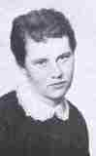
Peggy (O’Neill) O’Reilly (60)
maggie@pinecrestbuilders.com

Left to right: Carolyn Rodgers, Karen Ross, Elsa Coleman. 1958-59.
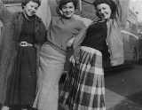

P. S. Melly Smith, Sherrell Melton and I are going to Kansas City reunion in Sept. We’d love to find our good friend Carolyn Rodgers. (Editors Note: Peggy sent me several other pictures and I will be using them in upcoming issues.)

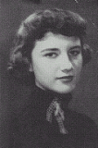
Suzanne “Snookie” (Garrison) Mayo (54)
Sgmayo54@aol.com

In response to Craig Barnes' account of the Teenage Club, I would like to make a few corrections!! Craig was on the right track, but the house on Regents Street was called The Winfield House. It was originally owned by the wealthy socialite, Barbara Hutton. She, in turn, lent/gave/sold it to the US as a residence for Joseph Kennedy and his family when he was appointed Ambassador to Great Britain before WWII. I believe this is the correct story. While we were in England, it was used as the Officers club. The TAC did meet in the garage and we had formal dances in the main house.

Craig did bring back a lot of memories and I was delighted to know, as a young girl, I had brightened his world a little.

Reunion News
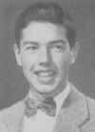
Bob Lyle (54)
Robvlyle@cs.com

More details will follow in the next few months.

To: Bushy Park Alumni, Classes of 1953 – 1956
From: Bob Lyle, Class of 1954
Re: Our next reunion in Nashville in 2008

It’s official! Our group will be meeting in Nashville on the Sunday through Tuesday, October 5-8, 2008. The place will be the Guesthouse Inn and Suites which is in the Music Valley area about a 15-20 minute drive northeast of downtown Nashville and just a few miles from the airport. The Grand Ole Opry is located in this same area.

Events being planned are an informal gathering with food and beverage at the Inn on Sunday evening, a reunion banquet at the Inn on Monday evening and a luncheon cruise on the General Jackson Showboat on Tuesday.

As an added attraction, we are planning to obtain a block of tickets for the Grand Ole Opry for Saturday night, October 4th. So, if you can arrive early for the reunion you may want to take advantage. We will need to know well in advance how many to reserve.

In due course you will be receiving more details on registration, etc. In the meantime, mark you calendars, and you can go ahead and make room reservations. Rooms will cost $73.00 per night plus 14.25% tax. The Inn is offering the same price per night for us for the 3 nights preceding and the 3 nights following the reunion. To get this group rate you will have to call the Inn directly at 615 885 4030 (the 1-800 number will not work for this event).

You can easily research the attractions and activities around Nashville. There is a huge amount of information on the Internet.

Please let me know if you are thinking about joining us so that we will have an idea of how many to expect. We already have some volunteers to assist with the reunion but we could use more. If you have not already volunteered and would like to help out, please let me know. Best wishes to everyone.
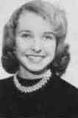
Sherry (Burritt) Konjura (57)
sherger@juno.com

In the article I wrote about Kansas City, I mentioned a local favorite BBQ hangout. Thanks to some information from Fr. Sheldon Peters, I can now recommend another place, for those of you who intend to come to the reunion and love BBQ. According to Fr. "Pete" , in his opinion "Fiorella's Jack Stack Barbeque...(is) by far, the best BBQ in the KC area. One of his places is right down by Union Station."
Just thought I'd send along this news from someone who is "local" to Kansas City and knows what's best. We'd welcome any and all input from those of you who happen to live in or around KC (or who have lived there in the past).
Mini Reunions
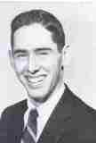
Tony Taylor (58)
usna1964@earthlink.net
For those who read my story, "A Continental Sojourn..." about the
summer of '57 when Ric Henslee and I rode our bikes around Europe, you will recall that a side story in Chapter 5 told about when Chuck
Stewart and I, and three of the prettiest girls in the Class of '58, went to Paris during our Easter break in April 1958.
It just so happened that in late March of this year my dear wife, Gitta, and I happened to be on the East Coast for a few days and made an unplanned visit on Dan and Sandy Frantz in their lovely home in Easton, MD. It was the first time we had seen each other since graduation in London so many years ago. There was so much to talk about, but never enough time... we promised to get together again soon.
And less than two weeks later on the Saturday before Easter, Gitta and I drove up from Redmond to Whidbey Island, Washington, to join
Kris (Ludlow) Ravitz and her husband, Ted, for a delightful Parisian déjeuner (complete with French onion soup, quiche, salad, and champaign) to celebrate 49 years since the "Bushy Park Five" went to Paris and attended Easter service at Notre Dame. As we dined, we listened to recordings of Edith Piaf singing "La Vie En Rose" and "Sous le Ciel de Paris," among others. After lunch we called both
Sandy (Kosanke) Frantz and Sandy (Johnson) Thomas to tell them that Kris and I had raised a glass or two to them and to all of us "kids"
who spent some memorable days one April in Paris. We tried to call Chuck, but we had a wrong number, but I am sure he must have heard the cork pop when we opened the champaign.
I am including some photos taken during both of these recent memorable occasions with Kris, and with Dan and Sandy Frantz. Hopefully this was just a practice drill for when we need to get together next year to celebrate 50 years since Paris... hey, Chuck, how about footing the bill and taking us all to Paris for a reunion in 2008?
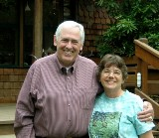

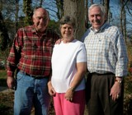

This and That

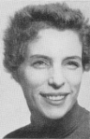
Gail Kelly (Faculty)
martha.kelly@virgin.net

Gary - below is a story written by my son - use if you think enough of the gang would be interested. When Gerry spotted Erin in her daddy's Central letter jacket he said, "Oh, look! A little Bobcat!" Tickled her, of course - cheers, Gail

America returned to the UK last night (13 March) to kick off the first major tour of the country they have undertaken for something like 30 years. Former London Centralites Dewey Bunnell and Gerry Beckley headed the five-piece band four of whom have been together at least 25 years. They kicked off their tour at the Hammerson Odeon (now the Carling Apollo) with great 23-song set that included songs from across the years and took them from the early days right through to tracks from their new album which was launched recently. Here & Now. Classics included Venture Highway, Don’t Cross the River and Tin Man. Great new tracks included Indian Summer and Hollywood. There was a nod to the Mamas and Papas with ‘California Dreaming’. It was all great. Of course they concluded with a rousing ‘Horse With No Name’. The concert was attended by Sir George Martin, America’s producer for four albums –and, of course, the man who produced the Beatles.
I took my daughter (and very good sport), Erin, 11, along. We met up with my brother, Duff, and we had a great night. Afterwards Dewey & Gerry were kind enough have a picture with Erin and myself before racing off by bus to be with family who ere there. We feel privileged to have been there and to have met them. Thanks guys! Come back again...soon. Picture attached: Dewey, myself (mouth open!), Erin & Gerry
Sean Kelly - Class of ‘78
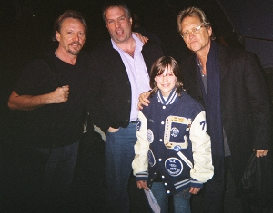

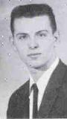
Robert Harrold (60)
rharrold@harrold.org

Our BushyPark.org ISP (Internet Service Provider) host in Los Angeles (where the server computer is located) has turned on statistics tracking. It may be of interest to visit the statistics page and see what pages, keyword searches, total unique visitors, etc. were. Some of the keywords searched and pages visited are surprising. They are good indicators visitor interests re Bushy Park and alumni. This kind of information can be useful when planning Bushy Park web page changes & additions, related articles, gatherings, newsletters and so forth. So far, it is available quarterly. The one area that didn't compute was the geographical locations of visitors, hopefully that will be fixed. A link to the page is. http://stats.bushypark.org

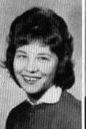
Susan (Miller) Dalberg (62)
Wolfpaw81@aol.com

Update—The address where each of us, if we wish, can adopt a solder is http://anysoldier.com/ or http://anymarine.com

Another Story Written By One Of Our Classmates

(Editors Note: This first chapter is a little long. I was unable to find a place where I would feel comfortable stopping it and putting the rest into the next issue. I apologize for not having a picture of Walt but I could not find one in the files.)

BICYCLING EUROPE ON $1.00 A DAY:
A Cold War Geographic and Cultural Memoir
--------------------------------------------------------

(INTENDED AUDIENCE AGE 11-17, YA, Young Adult)
DRAFT

Copyright 2007, Walter E. Hunt
(Format 6x9, 12 pt. Times New Roman)

INTRODUCTION
From Wikipedia
(Edited by the author.)
The Cold War was a period of conflict, tension and competition between the United States and the Soviet Union and their allies from the mid 1940s until the early 1990s. The main U.S. allies were Western Europe, Japan and Canada. The main Soviet allies were Eastern Europe and China. The rivalry between these two superpowers involved their military; espionage; industrial and technological developments; costly defense spending; a massive nuclear arms race; and many proxy or "indirect" wars.
In 1947 the term "Cold War" was introduced by Americans Bernard Baruch and Walter Lippmann to describe tensions between the two former wartime allies. There never was a direct military engagement between the U.S. and the Soviet Union, but there was a half-century of military buildup, and political battles for support around the world, including significant involvement of allied and soviet satellite nations.
Although the U.S. and the Soviet Union had been wartime allies against Nazi Germany, the two sides differed on how to reconstruct the postwar world even before the Second World War ended. Over the following decades, the Cold War spread outside Europe to every region of the world, as the U.S. sought the "containment" of communism and forged numerous alliances, particularly in Western Europe, the Middle East, and Southeast Asia.
There were numerous crises that threatened to escalate into world wars but never did, notably the Korean War (1950-1953), the Cuban Missile Crisis (1962), and the Vietnam War (1964-1975). There were also periods when tension was reduced as both sides sought to achieve a peaceful standoff with each other. Direct military attacks by both sides were avoided because of the prospect for massive destruction through the use of nuclear weapons.
The Cold War drew to a close in the 1980s following the launching of Soviet President Mikhail Gorbachev's reform programs. The Soviet Union consequently surrendered all power over their Eastern European satellites and was dissolved in 1991, which most mark as the official end of the Cold War.

PART ONE - ENGLAND, 1952-1953

Chapter 1 - Late August, 1952, London

The shrouded shoreline of the Isle of Wight was barely visible through the damp and dense fog as our ship eased toward its berth in Southampton, England. Our marvelous seven-day journey on the troop transport ship USS General William O. Darby was ending. (PHOTO of ship)

Dad had already made the trip to England about three months earlier, and met Mom, Sister, and me at the dock in Southampton on this foggy, rainy day. He was an officer in the U.S. Air Force on a diplomatic assignment to the American Embassy in London. I had just turned 14, and now I was an American teenager abroad, getting ready for my first year in high school.

My memories of England started with the fog, and the same day encompassed Stonehenge, the spectacular stone monoliths of Southern England, barely visible in the distance as we drove by them. Except that we drove on the wrong side of the road, the trip to London was otherwise uneventful.
(PHOTO of Stonehenge)

We lived a stone's throw from Putney Bridge, on the Fulham side of the Thames River in a spacious flat owned by Mrs. Mary Francis Evans, #5 Hurlingham Court. This was on the West side of the City of London. Mrs. Evans lived in the flat below us, #2. Both apartments faced directly out onto the Thames River. Her thirty-something daughter, Penelope, lived with her and was a pediatric nurse at one of the hospitals in London.

Our phone number was REnown 2019. I was surprised that the phone number had only six digits. Where we had lived in Virginia, the number had seven. London was so much larger—more populated--and I guessed the English had a better way of doing things.

The first morning we were in our flat I went out to the sidewalk and discovered a clever, yet official-looking sign attached to a lamppost: "Please curb your dog," along with the fines that would result if you violated the law. That's nice...no dog poop in the sidewalk. (PHOTO of sign) The lamppost was for a gas light, and every night just before darkness set in, a man came around and lit it.

One Saturday afternoon Mrs. Evans and her daughter entertained us for 4:00 o'clock tea in her flat. She asked if I knew how to waltz. "Every proper young man must know how to waltz," she announced. I didn't know, so she proceeded to give dance lessons on the spot. She also stepped me through the tango and the fox trot. Penelope showed how to hold a dance partner and told me to "Engage them in conversation." When asked what I should talk about, she said, "Ask them something interesting, like 'Do you like rope?'" I have used that question countless times over the years, even when not on the dance floor and a laugh was always followed by an interesting response. Never let it be said that the English are without a sense of humor.

The tidal action of the Thames estuary was amazing. During low tide, the river was down so far that all the boats anchored at various places along the riverbank, and in the water, rested on the muddy bottom of the river. When the tide flowed back in, the water lapped right to the top of the wall along the edge of the river, refloating all the boats--it must have been at least 10 or 15 feet from the top of the wall down to the river when the tide was out. Almost every day I could see 2, 4, and sometimes 8-person racing hulls going back and forth on the Thames. It seemed like a great sport that is something I have always wanted to do, but have never lived close enough to the right kind of lake or river.

I ventured across the river from Fulham into the business district of Putney almost every day, starting to experience the sights, sounds, and smells of this wonderful city. It cost sixpence (about seven cents at that time) to go to the cinema (movies). At this low price, I went as often as two or three times a week, and stood with the rest of the audience at the end of the movie and robustly sang "God Save the King." Most of the movies shown were American, but the English had great mysteries, and I was exposed to a lot of their culture through movies. The theater was quite large, with comfortably velvet-padded seats that rocked back, and a balcony that stretched high overhead.

I met a crusty, wiry Englishman--John Sluter--proprietor of the Raleigh cycle works in Putney. He had a perpetual cigarette hanging from his lips. Not long after that I talked my dad into buying two bicycles from Mr. Sluter--one a proper, staid, upright, black English gentleman's 3-speed, the other a racy, dropped handlebar sporty model, the Raleigh Lenton, 4-speed Sturmey-Archer hub-gear touring cycle--metallic green! The greatest adventures of my life were about to begin!
(PHOTO of cycle)

I spent every free moment in the saddle of the Raleigh. The 4-speed hub was wonderful, with an extremely low gear, and a moderately high gear. It was seldom necessary to use the gears in between, and I quickly skipped over them to get up to speed. I toured the environs of London after school and on weekends until the "Killer Fog" of the winter of 1952 practically shut the city down.

It took between 9 and 11 minutes to cycle four miles at breakneck speed to the American Embassy. The streets were level, smooth, and well maintained. Once I watched a street repair crew repaving a section of Regent's Street. Their method was ingenious, and I wondered why we had not imported their ideas to the U. S. They had a giant 8-foot-by-8-foot hooded blowtorch at the back end of a truck loaded with fresh asphalt. The torch heated up the existing asphalt, and a couple of workers then raked it. The truck dumped whatever new material was needed, and a roller immediately followed making the street as smooth as I'd ever seen. It was a great town for cycling.

During the periodic dense fogs, particularly the "Killer Fog" which came in December, bus conductors who normally rode the platform of the double-decker buses, taking fares, walked in front of the bus carrying a lantern in the daytime and guided the driver by shouting "Left a little," "straight on," "straight," "left to the curb," "all right, mate," "that'll do it." Life during that month or so when London had its historically densest fog was interesting. The fog sifted into our flat so you could see it from one end of a hallway; penetrated movie theaters--I went to one, sat in the front row, and could not see the movie clearly--closed schools; disrupted transportation; and made you hold a handkerchief or scarf around your mouth when you went outside. While walking downtown, I bumped into a light post, looked up, and saw a glow coming from the light. A number of elderly died from respiratory problems, and because of this fog, the British Clean Air Act passed in 1959, which signaled a significant conversion from coal burning to gas, and the cleaning of numerous municipal buildings, which were returned to their original, white, limestone color. I remember them as gray and soot-stained because coal was the primary source of heat. In fact, almost every room in our apartment had a small fireplace that we loaded with coal every afternoon to provide heat.

One Saturday morning Dad and I cycled across the Thames to Putney, to an antique shop to pick up two bed warmers. We tied them on to the back of our bikes and rode home. One was a gift for a family friend, the other we used every night, filled with hot water, to slide around under our flannel sheets to warm them up. (PHOTO of bed warmer)

I joined the local Boy Scout troop in Fulham, and swore allegiance to the King. At first, I was uncomfortable doing this. I thought maybe I could be branded or arrested as a traitor or turncoat. I decided to take a chance and worked toward becoming a King Scout, the British equivalent of Eagle Scout. The scoutmaster (we called him "S.M.") was a plumbing contractor with a son in the troop. I was two years older than most of the boys.

Their respect for "S.M." was truly remarkable. Our meetings were busy with knot tying, first aid, firemanship, and other general chaos with a variety of skill-building games we played, some of which I had played with other scouts in the U.S., but most were new. I earned several merit badges, which are sewn on my merit badge sash. Thursday nights after the troop meeting, S.M. invited me up into the bell tower to help him go through the weekly process of winding the clock and bells so he could rehearse for the Sunday morning church service. It became a regular ritual. What a treat, to help crank the bell mechanism, then sit in the tower and listen to the bells as "S.M." played them. A couple of time he let me ring some random bells, but I obviously had no musical talent. (PHOTO of Fulham All Saints Church)

I cycled all over London, going through the vendor carts on Penny Lane, which could be compared to a huge flea market. I stood outside Buckingham Palace and inspected the resplendent palace guards in their bright red coats and tall black furry hats; toured all around Piccadilly Circus (which could be compared to Times Square in New York City); and Sundays I went regularly to Speaker's Corner--the gathering place at the corner of Hyde Park across from Marble Arch, where anyone with a box, step ladder, or chair could stand up and pontificate on any subject of their choice. It only took a few minutes to gather a crowd. I liked to heckle the Communists--their philosophy was so contrary to what I was raised to believe in our capitalistic society. I witnessed arguments, cheering, jeering, and all manner of interaction between the speakers and small crowds that gathered around them. The marble arch in the background was exactly that—a huge marble arch. (Picture?)

I rode the red double-decker buses as often as possible. If the conductor was upstairs collecting fares he would signal the driver to start again by stomping his foot on the floor. I learned that if you jumped aboard, ran upstairs and sat over the driver and stomped your foot the bus would start. It was probably dangerous but still great fun to get the bus to pull away from the stop while passengers were still trying to board. The favorite expression from the conductor as he took fares was "Ta, mite" (thanks, mate), or "Ta, luv." It seemed all the conductors spoke Cockney. Cockney was a peculiar and interesting dialect, which I think all Londoners at least tried to mimic. You were entitled to call yourself Cockney if you were born within earshot of the bells of St. Mary Le Bow church, in Cheapside, an area in East London. A joke at the high school was that you were a true Londoner if you could pronounce Trafalgar backwards. I think this was an American joke. I asked some English friends to pronounce Trafalgar backwards, and they just looked at me blankly.

Next to the American embassy at Grosvenor's Square was a partially bombed building with an exposed staircase going up the side of a wall into nowhere. I asked several people why they just didn't tear it down and the answer was the same: "We keep it as a reminder of Hitler's buzz bombs.
(PHOTO of staircase)

The English were a little reserved, subtly humorous, and extremely polite and considerate. There was little bumping and poking as crowds entered the tube (subway), or climbed into the double-decker buses. Everything was civilized. Their outlook on Americans still involved references to the colonies. It was common to be referred to as a Yank from the Colonies. We also had little control of the English language, that is, we spoke poor English.

Their usage of the language was amazing, with conversation peppered with words I had never heard before, not just the usual differences such as lorry (truck), spanner (wrench), and bonnet (hood), but with a vocabulary that did not come to me for years. Boys my age used words that I had grown up calling "two-bit" words--long, complicated, little-used words that no one understood. However, to the English these words were everyday usage.

The King's Guards at Buckingham Palace were the most rigid, brightly uniformed, and stoic guards I ever encountered. However, I did coax from one what his tall furry hat was made of. "Biskin," was the only word he said through his clenched teeth. I thought he said "biscuit," but concluded later he said "bearskin," but maybe his chinstrap was too tight, or maybe he would be punished if his sergeant saw his lips move.

The British Museum was the most fascinating museum I had ever seen, especially the archaeological exhibits with the bones of numerous dinosaurs. I spent hours at the Science Museum, with all its interactive operating gadgets that captivated me on numerous repeat visits. I went to the Tate Gallery, which was my introduction to fine art. Their international collection of famous artists was unexcelled, although at that time most were unknown to me. The ravens at the Tower of London were the largest black crows I had ever seen. They were waist high to me and I knew I would have a problem if one decided to attack. Nevertheless, they seemed docile enough. As long as the Tower has the ravens the British Monarchy will survive. The Crown Jewels were stored there, and the piles of diamonds, rubies, and emerald's were so large I was convinced they had to be fake. Maybe not. Westminster Abbey was also on one of my trips. I strolled through the inside of the church and saw names from centuries before, names that I had only read about in books--kings, queens, writers, poets, and artists. There were tourists inside with huge pieces of butcher paper and chunks of crayons and charcoal, spread out on the floor making rubbings of some of the plaques commemorating these famous people. The plaques were actually grave markers!

The architecture of London, and all of England, was fascinating. Our culture in the U. S. dated back three hundred years, while the buildings of London, and bridges, cathedrals, castles, and I think some of the inhabitants dated back to the 11th century--the time of Knights of the Roundtable, Robin Hood, the signing of the Magna Carta, Shakespeare, and all the movies I had ever seen of the Crusades. There was a definite air of antiquity, of permanence, of enduring tradition in London. In the artsy area of Kensington the sidewalks were six feet wide, with three or four of these six-foot wide steps going all the way back to shops that sat thirty or more feet off the street. I was told that these steps were mass burial pits where people who died during the Black or Bubonic Plague of the 14th Century were buried.

There were many castles dating from the Middle Ages, and probably twice as many ruins on hilltops scattered all over England. The architecture of homes in small villages was medieval, post and beam, and they had no doubt been continuously occupied since being built. I always wondered how they had been modernized with electricity and running water.

Retail shops in London were highly specialized: if you wanted meat, you went to a meat shop. If you wanted bread, you went to a bakery. If you wanted chocolate you went to a shop that sold "sweets." In those days, the concept of the "Supermarket" was not generally available in London.

Fish and chips (French fries) from a local cafe became my favorite fast food. Giant pieces of deep-fried fish were wrapped in a half sheet of newspaper shaped into a giant cone--the battered fish piled on top, chips underneath, all generously sprinkled with salt and liberally doused with malt vinegar. After savoring the last chip, it was customary to tear off the bottom of the cone and drain the remaining mixture of salt and vinegar into your mouth.

Fresh eggs did not sell by the dozen, but by the each. Moreover, they were still rationed from the war. Meat, chocolate, and other sweets were also rationed, but there were four in my family, and Dad was gone a lot to Germany, so we had plenty to go around. English chocolate was wonderful, and even though we had to have ration coupons to buy it, there seemed to be an abundant supply. Eggs were stacked in storefront windows in giant pyramids. If you bought six eggs, they were carefully placed into a cone-shaped paper bag with the top twisted shut, and loaded into your shopping bag or net.

Defeathered chickens hung inside the butcher shops, and outside there was a wide variety of unplucked birds hanging by their heads along the sidewalk--pheasants, ducks, geese, and guinea hens. Mom said that they were not ready to buy until they were "ripe," that is, they were ready to drop from whatever held them. Yikes! The British called sausages "bangers." The bangers we had in those day, just after the Second World War (seven years!) had more meal, or filler, than I was used too. The taste was still unique and quite good. On trips around town I frequented the cafeterias, usually selecting snacks from a dazzling assortment of custards and gelatin deserts, which cost sixpence, or less. A complete lunch usually cost about a shilling (14 cents).

Later, in a first year English class in college, I wrote a research paper titled "Voracious Victorians," inspired by many of the "fast food" experiences I had in London. I argued that fast food originated in London in the late 1800s, and received an "A+" for a well-documented and eloquent presentation. The professor wrote "outrageous" at the top of it.

At the grocers you could buy Wheaties, Cheerios, Kleenex, Colgate toothpaste, and all manner of what I thought were "American" products that originated in Battle Creek, Michigan—the cereal capitol of the Universe. It never occurred to me that all these brands had been "internationalized." In my own, immature way I thought the English versions were counterfeit because the packaging was slightly different—not quite as "slick," or colorful. I also entertained the notion that perhaps they had originally come from England, and were exported to the U. S. It was all a wonderful mystery.

Our family went out for dinner one night to a fancy Italian restaurant in Kensington--one of the more snooty, artistic areas in London. The spaghetti I ordered was covered with a thin tomato sauce with hardly any meat in it. This was my introduction to a very different type of Italian cooking than I had grown up with back in the States. Mom was of Mediterranean descent and cooked many Greek and Italian recipes. I never knew if this was a typical English recipe or if meat was still scarce in the restaurants.

Once I was told that tea in Scotland was not served properly unless your spoon stood straight up in the cup. On another occasion, I was told that Guinness beer was a woman's drink, served with a slice of bread and a butter knife to spread it.

Dusty Bowers, who was two years older, was a friend at the high school that I had roomed with on the trip from New York to Southampton. He and I liked to walk through downtown London on Saturday mornings. On one such all-day excursion, we wound up walking around Marble Arch late in the afternoon, and started following two young beautiful French girls. It was fun. They would stop in front of a shop window to gaze at the display, and we would go around them and stop at the next window. We played this leapfrog game for a couple of blocks before we stopped to engage them in conversation. They were from Paris, on a break from school, just playing in London. We walked for several hours, holding hands, and finally kissed on a bench in Hyde Park. The park was closed when we entered it by stepping over the 2-foot gate that surrounded the entrance. We strolled the length of the park, saw them off on a double-decker, and started our journey home. The park was eerily deserted the whole time.
(PHOTO of Dusty)

Most Sunday afternoons I went to the American Teen Club to hang out, shoot pool, and dance to the latest rock and roll tunes. (Dusty Bowers was the king of the dance floor, but in spite of all my efforts, I have never overcome two left feet.) Riding the tube was cheap, easy, and took me within a short walk of the teen club, which was in Regent's Park. The teen club was in the former carriage house of the Winfield House, a resplendent mansion with its own history. I still have a large red "L" on a plastic placard as an interesting momento from the teen club. In England, when you applied for a driver's license, you had to put one of these large L's on the front and rear of your car, to indicate to other drivers that you were a "learner." At the teen club the L was given to a rookie dancer. (INSERT article on the Winfield House)

I got on the Circle Route tube to start my trek home from the teen club late one Sunday. The Circle Route made a huge loop around the central part of London—like the hub of a wheel. I had to transfer to another line (a spoke) to get home. At some point on the circle, I fell asleep, and woke up later with no idea of how many times the train had made the loop around town.

One day after living in London for just a few months, I went into a shop to buy some paraffin (kerosene) for the space heater we used to warm the kitchen. The shop owner that sold heating fuel asked what part of Wales I came from. I took this as a supreme compliment. It could have been a joke. I think he judged from the accent I had developed that I was from Wales--a Welshman! I never met anyone from Wales, so I never had the opportunity to assess the accuracy of this dubious compliment.

Mom went shopping at Harrods from time to time. This was the largest, most resplendent department store I had ever seen. They had at least one of everything you could imagine. She bought me English clothing, a Harris Tweed jacket among other items. When properly outfitted, I looked very much a young Englishman. The jacket lasted for about ten years, until I outgrew it, and it still had many miles left.

Soccer was the most popular team sport in England, and I thought the American high school I attended should have a soccer team. I talked to our football coach and a number of other teachers trying to find a sponsor, but no one knew anything about the sport. The history teacher finally agreed to be our faculty sponsor and we formed a small team. We were all self-taught, since none of us had ever played the sport before. We played a number of local school teams from around the area, but never won a game. In fact, we were very humiliated every time we played, with scores like 0-8 and 0-14, but it was all in fun. Our competitors knew all the tricks that we did not, like kicking our ankles when they tackled us to take the ball away. Maybe the best part was the cheerleaders from the high school who came to the games and urged us on! Once they cheered "Yoo hoo, Walt, we love your legs."

One Saturday I cycled about 20 miles into the suburbs to see the international air show at Farnborough. I marveled in particular at a large twin-engine, turbo-prop, cargo transport that flew over the field powered by only one engine. A remarkable feat! I met a bloke my age who was particularly captivated with the Kodak 35mm camera Dad had let me take with. After awhile he finally asked if he could "have a go at taking some pictures." He carried the camera around his neck for several hours while we took in the air show. At one point, he had to go to the loo (bathroom). I waited outside. When he did not come out after a few minutes, I went in. He was nowhere to be found. I went out the entrance on the other side of the men's room and saw him halfway up a nearby hill, headed for the exit to the air show. I overtook him in a few moments and had him pinned to the ground under me--scared to death.

Late in the fall of 1952, groups of us at the American School (Bushy Park High School) were recruited to form a square dance team to appear in the Festival of Nations. This was a festival of folk dances from around the world. We practiced for hours for this performance, held at Royal Albert Hall, the equivalent to the Kennedy Performing Center for the Arts, or even Madison Square Garden in New York City. We danced the "Texas Star" and one other dance. Our "caller" was one of the phys ed. teachers from the high school. The sold-out audience seemed to stretch all the way to the stars. This theater was huge, with layers of seats going up to a ceiling that was the length of a football field away! We kept looking at the Royal Box to see if the King or Queen was there. I don't think they were.
(PHOTO of Royal Albert Hall)

Not long after that Dad was transferred to the military attaché office in Frankfurt, Germany. We flew to Germany during semester break the end of January, 1953.


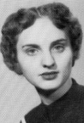
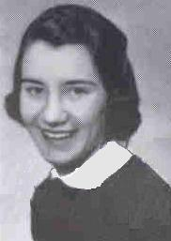
Coralie (Guertin) Lajoie (55)
Mondo19341@aol.com

I really like the changes you made in the newsletter. I really look forward to getting it every month. Sorry I haven't sent any articles to you in quite a while. Last July, I had a stroke and have finally gotten the medication straightened out. I am fine and very lucky, as I was astute enough to take a whole aspirin when I got home. ( Believe it or not I was at the hospital having a test} It literally saved my life. The neurologist was amazed that I had no residual effects from the stroke. She said I was the luckiest women she knew. I thank God for my total recovery.
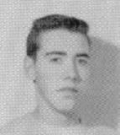
Ron Miller (56)
randb38@msn.com

Just wanted you to know that I really like the new style of the newsletter. Pictures of contributors enhance the mood and flavor of our days at Bushey. I have very much enjoyed reading each and every issue, especially people's memories of their time in England, of trips over, getting settled on the English economy, classmates and friends made, and events at school and out.

I have a story or two that one day I'll try to put on paper and send along. One of an interesting adventure on the last night of school in 1955 that I think some may find amusing. Thanks for all you do to keep the memories alive.

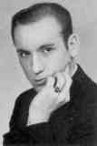
Rev. Aaron Peters, O.S.B. (57)
aaronosb@hotmail.com

I for one like the change. The pictures help place the names in memory context. I edit a newsletter for one of my submarine veterans groups. I know
the difficulties with photo editing and file sizes re: internet. You do a great job, Thank you for your dedication.
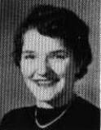
Diane Lund McMahon (58)
jmcmahon@stx.rr.com

I love the addition of photos. A great idea!!

Gail (Sawyer) Mitchell (59)
RMitch1886@aol.com

I really like the new format and the pictures! I can't tell you how many times I drag out my yearbook to look at the pictures of people who write in to remind myself who they are and now they are right there! Great idea. Thank you so much for all you do for all of us.

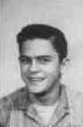
Neil Wolfe (59)
nwolfe@airmail.net

Great job! I like the new format! It helps me place the writers

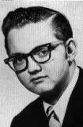
Terry Ennis (60)
TRENNIS1@aol.com

Love the new format. How neat can you guys be? Thanks.

