- 1 -

Bushy Tales
Dedicated to all who attended London Central High School at Bushy Park, London England from
1952 to 1962
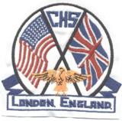
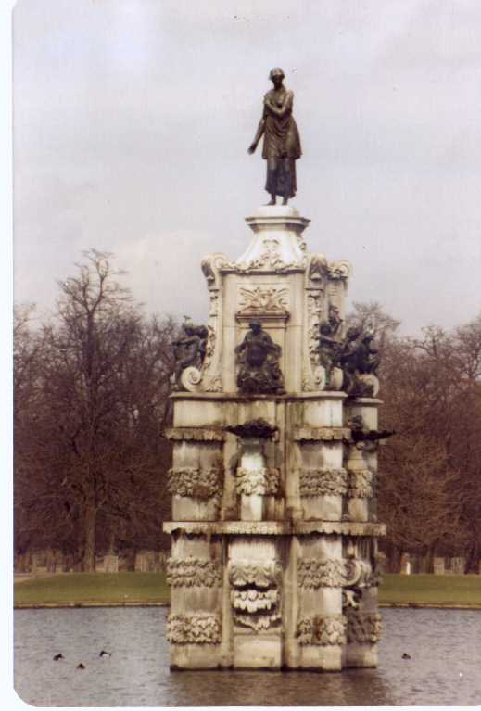

Issue #9 November 2007 Volume #7
Gary Schroeder (55), Editor gschroeder4@comcast.net
Visit the Bushy Park Web Site at http://www.bushypark.org/

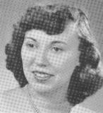
Class Representatives

1953 - Jackie (Brown) Kenny
JKYKNY@aol.com

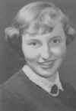
1954 – Betsy (Neff) Cote
betsycote@atlanticbb.net

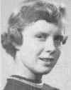
1955 – Nancie (Anderson) Weber
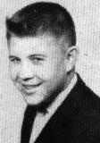
nancieT@verizon.net

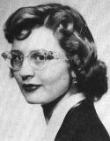
1956 - Glenda (Fuller) Drake
gfdrake@swbell.net

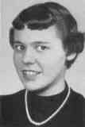
1957 –Shirley (Huff) Dulski
shuffy2@msn.com

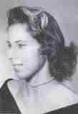
1958 – Pat (Terpening) Owen
CHS1958@sbcglobal.net

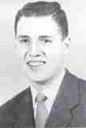
1959 - Jerry Sandham
j_sandham@comcast.net

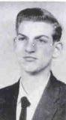
1960 - Ren Briggs
renpat1671@uneedspeed.net

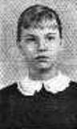
1961 - Betsy (Schley) Slepetz
bslepetz@comcast.net
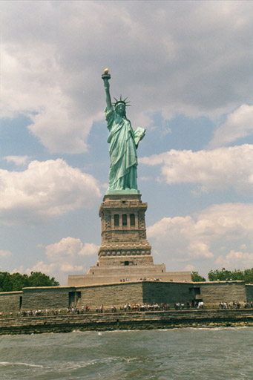

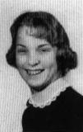
1962 - Dona (Hale) Ritchie
DonaRitchi@aol.com

Correction

In the last issue I used the wrong picture for Robert Herbold showing his new email address. This is the right picture and his new email address. Sorry Robert. Thanks to Connie (Newlin) Drennon (60) for keeping me straight.

Robert Herbold (62)
bobann095@yahoo.com

Roster Changes

New Email address:
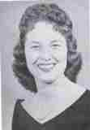
Rachael “Rusty”(Hockett) Hummell (59)
r.hummell@comcast.net

Look Who We Found
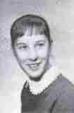
Ellen Hollingshead (59) Steele emsteele@theinsightworks.com
(Thank you Fred Buhler (58) for the information enabling her to be found)
Thank you for writing. My husband mentioned to Fred that I had attended Bushy Park, in 1957-58. I have not been in touch with anyone so it came as a nice surprise. I will go on the web page and register. Right now we are on a trip East, and are in Bar Harbor. I will try to give you some
information when I have access to service. I have my lap top with me, but do not always have access to the internet. Now you have my email address, you can reach me any time. I will be back home and again on our house WiFi on October 20th.
There are several people I would like to re establish communication with, but have lost touch. I guess Fred mentioned that my maiden name was Hollingshead. My father was a Sociology Professor at Yale University. He was in London for a year, on a Fullbright Fellowship and on Sabbatical, doing Mental Health Research at Maudsley Hospital. His
field was Medical Sociology.
We lived in Hampstead, and I rode the bus 3 hours round trip to Bushy Park for school. It was my Junior year in high school. We moved back to
Hamden, CT (where I grew up), and I graduated from Hamden High School in 1959. Then went to Indiana University. I met and married Russ Steele in 1963 and moved to Loring AFB, Limestone, ME. From there we moved 14 times in 17 years, had four daughters, all in different states. Russ retired as a Lt Col in 1980. We have been in Northern California since, tho Russ had a second career as a Lab Manager for TRW for 16 years, and a third career as a freelance writer since 1997.
My home address is: 12116 Horseshoe Lane, Nevada City, CA.
I am delighted to have been FOUND. Again, thank you for the email. I will be in touch, and will go on the web site.
Memories of Bushy

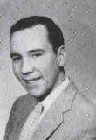
Ellis Young (59)
Eyoungf64@cox.net

I remember a couple of signs from 1954-1957:

On the grounds of Windsor Castle the speed limit was posted as "Dead Slow" and at a cramped hotel pub in Purton, near Swindon, each motorist was requested to "Please Park Prettily".

I was wondering if any of your readers recall other unusual signs?

Too bad digital cameras had not arrived on the scene during the Bushy days. They would probably occupy a 100 page newsletter.

Finally I was wondering which town / city contains the most former Bushy students? I know here in Oklahoma City, there are three. Salina, Kansas has one. Memphis, Tenn. has one.

Mini Reunions
Pat (Terpening) Owen (58)
nemoamasa@sbcglobal.net

Pat Terpening (58) Owen and her husband John had an enjoyable lunch with Fred (58) and Margie Buhler who were in Junction City, Kansas to pick up a new truck and 5th wheel. Pat and John drove over and met the Buhlers for lunch. A great time was had and Fred even had the name of an ex-Bushyite who hadn't as yet been 'found'.

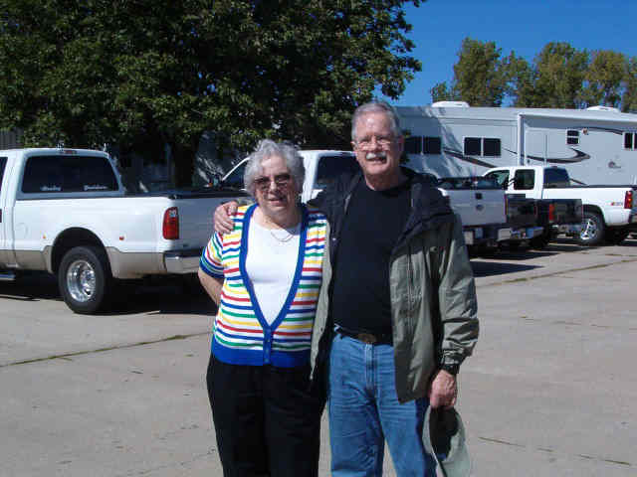

Reunions

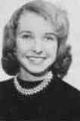
Sherry (Cheryl) Burritt Konjura (57)
sherger@juno.com

Class of 1957 - 50th Reunion
September 21 - 24, 2007

Kuddos go out to Bill Cooper who took over the task of planning our 50th reunion earlier this year. Despite the fact that almost every hotel room in Kansas City was already booked, Bill managed to secure a nice block of rooms at the Crown Plaza right downtown at a fantastic price, a Hospitality room where we could all meet and reminisce, a room for a banquet on Saturday night, and an amazing banquet menu complete with hors d’oeuvres beforehand.

We chose Kansas City with the thought in mind that it is right in the center of the country and gave the greatest number of people a shot at being able to get there. Our class only graduated 68 from Bushy Park and, to our knowledge 12 of those have passed away. We felt grateful to have 19 of our classmates at the reunion: James Baker, Carol Bassham, Helga Blanton Pepper, Barbara Bookhammer Luehrs, Vaikai Brown, Sherry (Cheryl) Burritt Konjura, William Cooper, Mary Dennard Nelson, Bill Grable Rees, Shirley Huff Dulski, Al Koltermann, David Mangold, Fr. Aaron (Sheldon L.) Peters O.S. B., Karl Phaler, Celeste Plitouke Brodigan, Sandra Scanlan Matlack, Cynthia Schofield Simmons, John Soule, and Richard Stillwagon.

Mary Easley Brokaw and Rosa Arns Pollock from the class of 1954 were there as well as Virginia Kaye Caldwell Jones from the class of 1956. Neil Clark Godfrey from ‘56 surprised us with a drop-in visit. Gary Culp, Jerry Ellis, Jerry Kelly, Michael Murphy, Pat Terpening Owen, Shari McClaran Parker, and Ruth Easley Tidwell joined us from the class of 1958.
Representatives of the class of 1959 were: Barbara Hamilton Board, Felicia Hardison Londre, George Lawson, Robert Reaves, and Judith Samms Stanford .

The class of 1960 were second in numbers: Patricia Brady Thurman, Geneva Dennard Miller, Helen Virginia Hays Pohly, Sandra Lee Klueh Denney, Linda McDowell Novosad, Mary Anne Meeker Brown, Sherrell Melton Bair, Peggy O’Neill O’Reilly, Judy Risler Covington, and Mel Smith Springborn.

Also joining us was Amy Walter Drescher, class of 1987 whom we enjoyed getting to know. Many spouses came, and we were also joined by Bill Cooper’s lovely daughter Meg who lives in Kansas, all of whom we immediately "adopted". We all remember the days when we were the "new kid" in a school, so in keeping with the open arms we all found at LCHS, we found no strangers among us at the reunion.

50 years! It doesn’t seem possible that it has been that long since most of us marched to Pomp and Circumstance at Wigmore Hall in London, and then immediately went our separate ways. Many kept in touch with good friends over the years, but most of us had no idea where the majority of our classmates wound up. Thanks to the Internet and the diligent work of Pat Terpening Owen, only about 1000 more alums of LCHS are yet to be found. That’s amazing!

Most folks drifted in throughout the day on Friday and found their way to the Hospitality room where Bill had a table set up with attractive name tags adorned with the school crest. There was one for each alum and also one for each attending spouse. As new people arrived there would be shouts of recognition, back slapping, hugs, and sometimes a few tears of joy. By Friday night one group decided to walk to a nearby restaurant and one group decided to stay and eat in the hotel restaurant. Unfortunately, the group who went out got a thorough soaking in a surprise rain shower on their way back to the hotel. Spirits un-dampened, most gathered in the Hospitality room and played catch-up until the wee hours.

Saturday saw much of the same. Some folks left the hotel to do some exploring around the city and some just stayed and visited in the Hospitality room. Our class President, Dave Mangold brought some beautiful blue t-shirts for sale which were emblazoned with the school crest and also "50th Reunion 2007". This beautiful work was done by his wife Vivian. Many of us were sporting the shirts before the day ended.

Late Saturday afternoon Fr. Aaron "Pete" Peters held a Mass in the Hospitality room honoring those members of our class who have passed away. The special intention for the Mass was for June McDaniel Kohonak who passed away on August 13th after waging a valiant battle against leukemia. We had a framed photo of June and her husband Ron which Pete put on the altar and flanked with candles. William Cooper, Gerry and Sherry (Burritt) Konjura assisted with the Mass.

Following the Mass we all scurried to our rooms to get ready for the banquet. We were all surprised by very attractive ceramic tile coasters designed with the school crest at each place setting. These were arranged for by Bill as a keepsake for everyone and were a big hit.

After cocktails and some delicious hors d’oeuvres we had a magnificent dinner with several entrees and a sumptuous array of desserts. Bill was presented with a blue t-shirt with the school crest on the back and "HSSH" standing for "High School Sweetheart" on the pocket. The shirt was accompanied by two musical cards – one from everyone and another labeled "To Our High School Sweetheart" from all the girls.

In recognition of all the hard work she has done in locating LCHS alums, Bill presented Pat Owen a beautiful wooden box which had one of the beautiful aforementioned tiles on the top.

Then came a huge surprise for our class Chaplin, Fr. Aaron "Pete" Peters. Pete had not been able to march with us at Wigmore Hall because his family was rotated back to the States just before graduation. So, Bill and Shirley (Huff) Dulski planned a special graduation ceremony just for him. Pete was given a Mortar Board to wear and, as Pomp and Circumstance played, he marched up the aisle to the podium where Bill presented him with his 2007 version of our Bushy Park Diploma.
The Diploma reads as follows:
This is to Certify that
Sheldon L. Peters AKA Father Aaron S. Peters O.S.B. has finally successfully completed a trip up the aisle with his classmates and, having walked the walk and hummed the tune, is therefore entitled to this Graduation Ceremony Diploma
Given (at long last!) On this 22nd day of 2007

William W. Cooper - President School Bored
Shirley E. Dulski - Unprincipled
David Mangold – Super inattentive

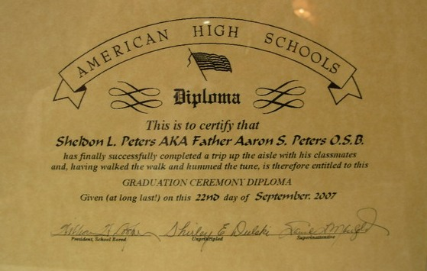

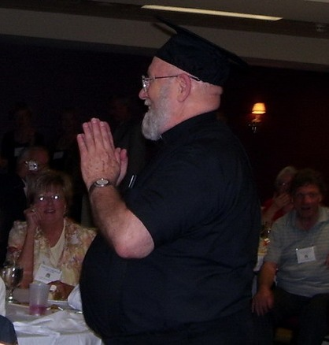

Pete was surprised and thrilled. He was also given a card signed by his fellow classmates.

Following all of our ceremonies, toasts were made (especially to June and Paul Francis whom we lost this year), 50's music was played for those who wanted to dance and, of course, we had class pictures taken. Below are two pics of the class of ‘57. Mary Dennard Nelson can’t be seen in one of them and Barbara Bookhamer Luehrs can’t be seen in the one showing Mary:
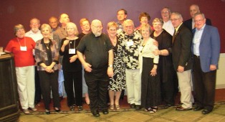

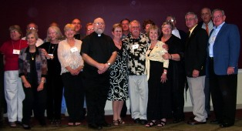

I do hope that others will send in class pictures as we didn’t get shots of every class. One thing we did do, however, was gather the attending members of the Senior Class Play, The Curious Savage together for a "photo op":
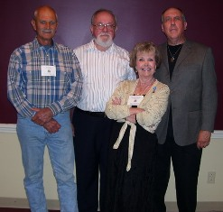
Only four of us were at this reunion - Karl Phaler (Hannibal), John Soule (Jeffrey), Sherry (Burritt) Konjura (Fairy May) and Bill Cooper (Titus). We had hoped one day to get all of the cast together at one time, but without our beloved June McDaniel Kohonak (Lily Belle) that won’t be possible.

After the banquet and the dancing, etc., many gathered back in the Hospitality room for more visiting, again until the wee hours. There were some goodbyes, some tearful, and lots of hugs to those departing early on Sunday morning.

Sunday morning a large group of us gathered in the lobby where those without cars were joined up with some who did drive. We all made the trek up to Atchison Kansas to Fr. Aaron’s main house, St. Benedict’s Abbey where we were invited to join the Monks in their prayers and singing in the Church before lunch. Then we gathered in the dining hall and had a delicious luncheon. Following the luncheon, Pete gave us a wonderful tour of the Abbey, which is magnificent and beautiful. There was an organ recital in the main Sanctuary at 2pm and many of us stayed for that. Although Pete is only there one day a week, as he serves the rest of the time as Chaplin to the Ursuline Nuns in Paola, KS, we can see why he loves the Abbey.

More attendees left for home Sunday evening, but those who remained all joined together and walked to a nearby restaurant for a nice dinner and one last chance to visit. Every time folks began to depart there were hugs, and "we’ll see you again next time", more hugs and a few tears.
Once again we have astounded the "civilians" in our midst by our love and respect for one another and our ability to pick up where we left off as if no time had transpired. We may have put on a few extra pounds, grayed a bit, earned the lines etched on our faces, but in our hearts we’re still the teenagers walking the halls of our beloved school. To those of you who could not or chose not to attend, know that you were missed.

Bill– thanks again for taking on this task! I believe a good time was had by all. So who’s going to step up and take on the responsibility for the next reunion?

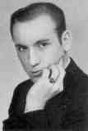
Rev. Aaron S. Peters, O.S.B. (57)
aaronosb@hotmail.com

One and all: I thoroughly enjoyed our get together. It was great seeing you all once again, and wishing that more would have/could have made it.
I enjoyed having those who could come to the abbey in Atchison for Midday Prayer, lunch, and the organ recital. And I am especially happy that there was not time for any of my monastic brethren to corner any of you to learn some of my teen age secrets.
I think we can all thank Bill Cooper for his hard work in arranging this again this time. I’m sure he deserves a purple heart, at the least!
Is it true that Jim Baker and his lovely Gloria are thinking of hosting the next one in San Antonio?
What a surprise to see Neil Clark Godfrey show up from the class of 56.
Let us keep in contact and
God bless you all.

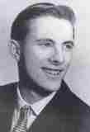
Mike Murphy(58)
OLDSALT1223@aol.com

Judy and I just returned from Branson Missouri and Kansas City. We attended the 2007 reunion. Bill Cooper class of 1957 hosted the event. We had a great time there. It was the 57 class 50th year. We had it at the Crown Plaza downtown. We both met people we had not seen in years. Since Judy and I were never in KC before, we took the local buses every where. Although our main mission was the reunion, we got there several days early to take in the sights. We also visited Branson Missouri prior to KC. We went to the Dick Clark American Bandstand theatre. We both had a good time. Looking forward to the next one.

Some pictures from the reunion. I know most of the names, but it cost you extra to find out who they are if you don’t know, LOL.
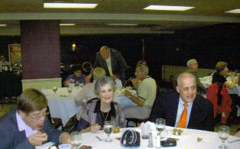

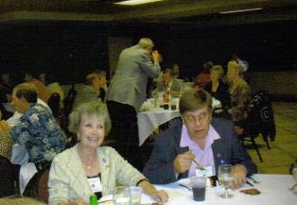

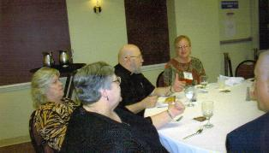

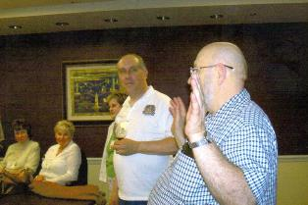

Breaking News: Wanda has added a new item to the Web Site – If you click on the “Of Interest” tab on the left side it will take you to a new page. Look for Kansas City reunion 2007 and click on it. Wanda has it set up in a slide show and can add more pictures if you will send them to her. The show is small at this time but is a work in progress and slides will be added as she receives pictures from you.
Great Job Wanda!!!

This and That

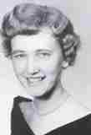
Lyn Peterson Stinnett (58)
roverlyn@yahoo.com

Hello everyone...who hasn't heard from me in ages...here is what I have been up to!

I am now working/living in Mongolia (again with the Peace Corps) so I thought I would have an interesting weekend entering the Gobi Desert Marathon Race. My goal was to get the T-Shirt at the finish line...!

We drove 1400 kilometers round trip from Ulaanbaatar, Mongolia and walked half the marathon....roughly 21 kilometers or 13 miles. Since we got lost several times we are not sure of the exact distance; in the end we did finish and I have the shirt!

Our group name was the "Ageless Amblers" and our motto was "Win or wear Orange" which is why the awful shirts....

I hope you enjoy the photos and hope to hear from some/all of you soon!
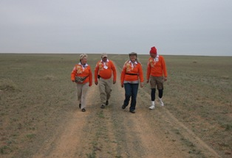

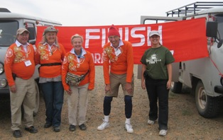

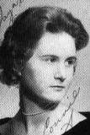
Connie (Newlin) Drennon (60)
conniedre@att.net

We returned last weekend from a trip that included just over two weeks in England. This was our fifth trip since I left in mid 60. Unlike previous trips, it just did not bring back any of the fond memories of the three years in the late 50's.

It was a shock to find the American Embassy guarded by London police and no sign of the Marines. I know that having my purse snatched by a clever lady "pick-pocket " two days before our return could be the problem, but I don't think so.

The world has changed so much and it really hit me on this trip. Americans, to me, now seem so out of touch with the living standards and advances in the rest of the world. A once warm reception also seems to have cooled mightily.

I have a question. Are we able to get the names of parents of our old classmates from the school registration records? After, in most cases, fifty years, it shouldn't hurt anyone or is it now covered under privacy? Could one get information under freedom of information? Just wonder if anyone knows the legal status. Do we have anyone who is a lawyer who would be willing to check this out?

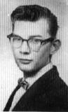
Jim Nichols (62)
sicnis_2000_2000@yahoo.com

I read, and re-read your news letter and was sadden by the passing of "our" Dallas Web. I did not know her very well. She and I, traveled in different social circles but still in the tiny world of "Busy Park". I was a bit of a scorned, while "Dallas" was an example of the ideal cheerleader.. with or with out "pom-poms.".

We traveled on the same bus (coach) every Friday/Sunday afternoons. We went to the same school. Lived at.(or near) the same base ( RAF Sculthorpe). She was always the center of a crowd. The "in crowd" was around her like a warm blanket on a cold day. Myself, and a few others, were at the back of the bus watching the smiling faces of that crowd.

Dallas was warm and very outgoing .I can still see her glowing face, and sparkling eyes to this day. Some of her warmth has passed to me, over the years.

I did not realize how much of a influence she had on my young and delinquent body. We were "ships passing in the night", but those ships carried more than just people. My reading the "news letter" reminded me of that time, and those smiling faces and bright eyes. Thank you for letting me share in the joy she has spread to this end of the long list of friends.

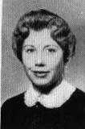
Margaret (O'Hallaron) Howard (62)
dnpnthee@hotmail.com

I was saddened to learn of Dallas Webb's passing for I shall always remember her as a beautiful, fun and vibrant gal. Though she and Judy were ahead of me in grade, I do remember a REALLY fun party at Dallas' house where we all stayed in a trailer they had out back. Such laughter and good fun. I really felt special that I'd been invited. I was also from Sculthorpe. Her sister, Cassell, and my sister Kathy were the same age and had been friends. I'm sure Dallas will be missed by all who knew her throughout her life.

The Story Continues
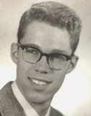
Walter E. Hunt (56)
walt@lobo.net

BICYCLING EUROPE ON $1.00 A DAY:
A Cold War Geographic and Cultural Memoir
--------------------------------------------------------
Chapter 7 - Easter, 1955, France and Spain

When the Easter break started, we loaded up the family chariot and headed south. Mom and sister in the back, Dad up front as the navigator. I did all the driving. Our destination was Madrid, Spain.

We drove through Germany, and cut over to Avignon, France. In an Introductory French class we learned a song about the bridge of Avignon--"Sur la pont d'Avignon." I was excited to see the bridge, but it turned out to be only a bridge. The romance of the song was more exciting than the bridge in person. We spent the night in Avignon and started out the next day toward Spain.

When we crossed into Spain, the architecture immediately became "Mediterranean." The houses were stacked on the hillside, and whitewashed. We passed through an area where caves cut into the side of cliffs and hillsides were being lived in. We saw women washing clothes in streams. I was amazed at the primitive aspects of their lives, but knew this was rural Spain.

On every hillside as we drove along were guards of Franco's dictatorship, standing, holding their rifles. Huge open trucks heaped high with oranges passed us constantly, on their way to market.

We pressed on into Spain and by nightfall were in the small town of Figueras, where we stayed in a small hotel. That night we went to the central plaza and strolled round and round, enjoying the promenade. There were a number of chaperoned young women in the circle.

I was first out early the next morning and strolled around the village. I passed a bodega that was open, and saw huge barrels of wine inside. I stopped and asked how much a liter of wine was. "One peseta." This translated to 25 American cents. When I told Mom and Dad, they went out and bought a leather bota bag (wineskin) at the local market, and had it filled at the bodega.

Our next stop was Barcelona. Mom went shopping for lace, and afterwards we went to a fine restaurant for lunch. I ordered baby eels, which I had never even seen before. They were white, deep fried, and you could see two little black spots on each head—the eyes. Nevertheless, they were delicious. When the waiter served us, he left a portion of each serving on the platter he brought from the kitchen. I asked him why he didn't serve us all the food we ordered. He told us that they keep a little food from each order to feed the kitchen staff.

We toured the cathedral that was visible from miles around. Its tall spires were on the highest point in the area. The cathedral had been under construction for almost seven hundred years, and was finally finished in the latter part of the last century. It was a beautiful example of Gothic architecture.

We were off for Madrid, and made good time when we got away from the coast and up on the plains of Spain. We drove over through Zaragoza and angled down to Madrid. We got to the center of Madrid, which was bustling with traffic and people, and stopped a police officer directing traffic to ask directions to our hotel. He was off duty the following day and offered to be our tour guide, for a small-unspecified sum, of course.

The next day we met our guide, and toured the Prado Art Museum which was filled with all the Spanish masters, and several other museums in the area, and late in the afternoon headed to the Plaza del Toros—the bull-fighting arena. I still have posters from the fight. It was gory, and not for the faint of heart. I suppose that if you are going to kill a bull for meat, this is a rather noble way for the beast to go. We sat in the shady section, which cost a little more, and took many pictures. I went "backstage" and watched the bull being pulled to the back of the bleachers, where he was strung up and slaughtered on the spot. The pageantry was splendid, the costumes beautiful.

The next day was a shopping day. Our guide took Mom out for more lace shopping, and Flamenco dancers entertained us while we ate lunch at a small private restaurant. That night we strolled down to the Plaza to join the paseo.

Since this was Easter week, there were long religious parades honoring the Holy Father, and the Holy Virgin. The costumes and statuary were colorful and elaborate.

The next day we started the long drive to Paris. We went over the Pyrenees to Limoges, France, and spent the night. The next day we drove to Paris.

The first stop was the Eiffel Tower. Seeing Paris from the top of the tower was sensational. In the afternoon, we drove to Versailles to go through the palace. Later, when we checked into the hotel, I asked my dad what the small sink was in the bathroom. He told me it was a footbath, which I believed for a while. It was a bidet.

That night we strolled around Paris. We went into the Metro to see how it compared to the Tube of London. The overwhelming odor was one of garlic. We watched a woman mix a salad in a large wooden bowl while she sat in the entry to a restaurant, and decided we would not eat there. At the restaurant, we had bifsteak avec pomme frites. We had heard that beefsteak and French fries in France were delicious, and we had heard correctly. The meal was indeed delicious. At the end of the meal, Dad—who was a graduate of the Army Language School in French—told the waiter he had a cordon bleu. The waiter replied with oui, and disappeared. While he was gone, Dad explained to us that the Cordon Bleu was a cook school in Paris, and the best chefs came from it. It was a compliment to the chef to be called a cordon bleu. A moment later, the waiter returned with a small silver platter with four small glasses, and a bottle of brandy. The label on the brandy was Cordon Bleu. Dad had outsmarted himself! We have always had a good laugh over this, at his expense.

The next day we drove home.



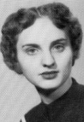
Coralie (Guertin) Lajoie (55)
Mondo19341@aol.com

Gary came across this picture in my Bushy Park archives. This is a picture of my roommate in 1954. I somehow had the foresight to put her name and the date on the back of the picture. Her name is Patricia Hundly or Hundley. I only recall that she told me she was from Florida. Her family shipped out the summer of "54". Has anyone ever tried to find her? Does anyone remember her?

