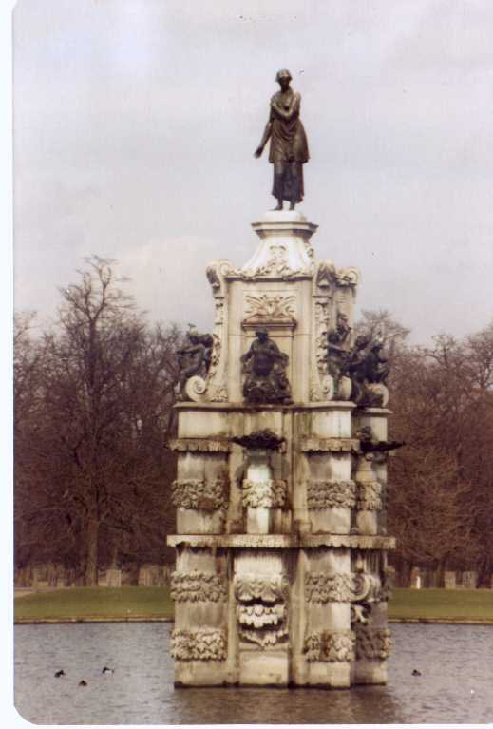

Bushy Tales
Dedicated to all who attended London Central High School at Bushy Park, London England from
1952 to 1962


Issue #7 September 2008 Volume #8
Gary Schroeder (55), Editor gschroeder4@comcast.net
Visit the Bushy Park Web Site at http://www.bushypark.org/


Class Representatives
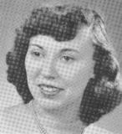
1953 - Jackie (Brown) Kenny
JKYKNY@aol.com
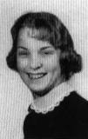

1954 – Betsy (Neff) Cote
betsycote@atlanticbb.net

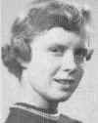
1955 – Nancie (Anderson) Weber
nancieT@verizon.net

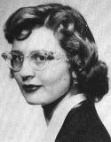

1956 - Glenda (Fuller) Drake
gfdrake@swbell.net

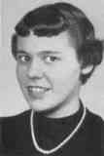
1957 –Shirley (Huff) Dulski
shuffy2@msn.com

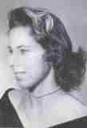
1958 – Pat (Terpening) Owen
CHS1958@sbcglobal.net

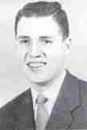
1959 - Jerry Sandham
j_sandham@comcast.net

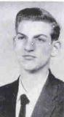

1960 - Ren Briggs
renpat1671@uneedspeed.net

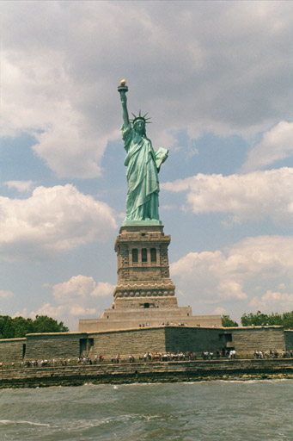

1961 - Betsy (Schley) Slepetz
bslepetz@comcast.net

1962 - Dona (Hale) Ritchie
DonaRitchi@aol.com

_________________________________

Roster Changes

New Email address:

New address:
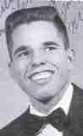
John M. “Mike” Hall (59)
MGHall@Q.com
11951 Dimond View Rd
Trinidad, CO 81082
719-846-1000

Diane Zumwalt Dorsey (56) (no picture available)
Email - We'll contact everyone as soon as we get a new one
1220 E. Beaumont, Park City, KS 67219
(316) 425-3686
________________________________

Look Who We Found

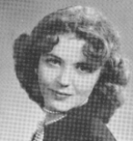
Connie (Carpenter) Golden (53)
conniecomcerteza@att.net
P O Box 1000
Norman, OK 73070
(405)288-2145 office, 360-0592 home

________________________________
Classmates Who Have Transferred To The Eternal Duty Station

Our love and prayers go out to the family and friends of our classmates who have gone on before us. We will miss them, yet we can find comfort in knowing that one-day we will all join them for the greatest of all reunions


Terry (Willamee) Sandry (60)

(Information below was received from Judy (Risler) Covington (60) )
Just found out one of our own, Terry (Willamee) Sandry (60) passed away two weeks ago. I don't know the details. Her address was: Terry Sandry, (her husband is Russell Sandry), c/o Santa Ana NWR, Route 2, Box 202A, Alamo, Texas. He is with the National Wildlife Refuge Sorry I couldn't provide any more information. Glenda Bentley Bucher was her roommate
______________________________

Reunion
Information

___________________________________

Mini
Reunions

_____________________________________
Memories of Bushy

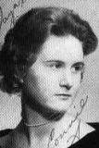
Connie (Newlin) Drennon (60)
conniedre@att.net

The Olympics made me think back to the Old Wembley Stadium and wonder whether it had been an Olympic stadium. No, it was not. The new Wembley stadium was just completed in March of 2007 replacing what I now

know was considered the hallowed turf of English football. While thinking of Wembley, I tried to find another Wembley location, the Wembley Town Hall, site of two Bushy Park graduation events. ( I think I was the only Bushy person to graduate in the town where I lived.)

Wembley is now incorporated into what is now called Brent. I located a picture of the town hall complex, but it didn't look at all as I remembered it. I e-mailed the Brent government site to ask if the old town hall still existed. The following is the reply:

"I can confirm that the current Brent Town Hall, formerly know as Wembley Town Hall until 1965, is the same building used in 1960. This building was built around 1937 and is a classic Art Deco structure. The graduation you talk about probably
took place in the Grand Hall which was re-named a few years ago to the Paul Daisley Hall to commemorate a local politician who died very young having been just elected to Westminster." Kind Regards, Mark Rimmer OBE, Director of Service

Does anyone know where other early graduations were held? I found it strangely comforting that
something of our past has not been bulldozed. I have often wondered if anyone has pictures of the 1960 graduation. Most of us who had just returned from that Rome trip were just barely awake. Why did they put us up on stage, facing the audience, when all we really wanted was a good night's sleep? I recently found a few snap shots taken at
the Rome airport the night before that graduation. I'll try to send them by snail mail if you will provide an address. Perhaps you can get at least one good picture out of three or four.

Some of the other Rome pictures are amazing because they show almost no traffic. Things are way different now. Seeing a parking place in Rome for more that a minute is rare. Bare street surface in day light is almost equally rare in the inner city.

London is a match, with public transport struggling to keep up, even with fares that seem astronomical.
_________________________________
This and That

Connie (Carpenter Golden (53)
conniecomcerteza@att.net

I am delighted to have found you and really appreciate all the work this effort takes on a continuing basis. Please feel free to give my address and email address to whomever requests it:

I have owned horseracing publications since the late 1970's in Oklahoma. Prior to this, I had a real estate office in Albuquerque, NM. I have two children. My son joined me after college and luckily stayed
with Speedhorse Magazine. My daughter has been living in Europe for fifteen years, eleven in Poland writing, consulting and film making. My son Andy has twin girls who are starting their junior year at OU.

There was such a nice group of people at Bushy Park. Can't wait for news about them. And Jackie was always a sort of gang leader! Well anyway, I can't wait.
Hope I'll learn what happened to Ray Allen Algren. He was my special boyfriend.
____________________________________

Letters to the Editor

__________________________________

Now for some fillers to finish out the page.

Comments Made in the Year 1955!
That's only 53 years ago!
'I'll tell you one thing, if things keep going the way
they are, it's going to be impossible to buy a week's groceries for $20.00.'
'Have you seen the new cars coming out next year? It won't be long before $2,000.00 will only buy a used one.'
'If cigarettes keep going up in price, I'm going to
quit. A quarter a pack is ridiculous.
'Did you hear the post office is thinking about charging a dime just to mail a letter?'
'If they raise the minimum wage to $1.00, nobody will be able to hire outside help at the store.'
'When I first started driving, who would have thought gas would someday cost 29 cents a gallon. Guess we'd be better off leaving the car in the garage.'

It is that time again for the Bushy Park Central High School
Gathering 2008 and the Class of 1958 50th Reunion
October 10th, 11th, and 12th 2008

We have reviewed several locations and hotels and have selected the Dallas / Fort Worth area. As you may not
know, Texas has the second highest number of residents that attended Bushy Park. So expect all of them to be
there.
Page two of this letter will provide you with the hotel selection and phone number for you to call for reservations. When you call PLEASE inform the operator that you are with the Central High School, London group. That will get you the special rate we have negotiated.

The hotel we have selected is the Marriott Dallas/Fort Worth Airport South. It is a primarily a businessman hotel during the week. The room rates are normally $239 a night. We have worked it out with the Hotel, and with our large group, we will get the same rooms for $99.00 a night.
In accordance with Marriott International, the DFW Airport Marriott South is now 100% Non Smoking in all guest rooms, meeting space, public areas, restaurants and bars.

The committee selected this hotel for it’s location. It is only 4 miles from DFW Airport and offers complimentary 24-hour Airport shuttle service. It is only 12 miles to Dallas and 15 miles to Fort Worth. South on state 360 from the hotel 12 to 15 miles is Interstate 20. There are 3 high rated RV Parks just east or west on Interstate 20. (see page 4 for listings)

Reservations are your responsibility. The last day to reserve your room is September 5th. We have a block of 75 rooms set aside. The hotel has 295 guest rooms so we can go over the 75 rooms and receive the same rate. However, after September 5th you will not get the group rate.
Please make reservations early if you plan on attending. If for some reason you cannot attend, you may cancel your reservation with 72-hour notice.

The schedule of events is as follows. Friday Oct. 10 is arrival. Saturday Oct. 11th we have reserved a banquet/hospitality room from 8:00 am to 5:00 pm. The Class of 1958 is having a special dinner planned outside of the hotel Saturday night. Information will be provided by their committee. Sunday Oct. 12th we have scheduled a luncheon at 12:30 for our Gathering festivity. The banquet/hospitality room is reserved from 11:00am to 5:00 pm. You will note that we have left the evenings open for you to get together with old school mates and friends for your own entertainment. Monday Oct. 13 we have a small hospitality room reserved and it will be departure day.

Please print out page 2 and 3. They will provide you with the information you require. Like all the prior Gatherings, we have costs to cover and we are having a luncheon. This information is on page #3 and must be mailed to the committee by September 5th.

SEE YOU IN DALLAS/FORT WORTH OCT 10TH, 11TH, AND 12TH

Hotel reservations and information

Hotel Marriott Dallas/Fort Worth
4151 Centerport Blvd.
Fort Worth, Texas 76155

Location 4 miles south of Dallas/Fort Worth Airport just off state 360

Marriott Reservation 1-800-228-9290 or 1-800-431-8162

All reservations must be accompanied by a first night room deposit, or guaranteed with a major credit card. Hotel will not hold any reservations unless secured by one of the above methods.

Remember to say you are part of the Central High School London for the room rate

Cut-off date September 5th, 2008

Hotel information
**295 guest rooms (219 king bed and 76 doubles
**200 of the guestrooms are designed as “the Room that Works”, a Marriott
concept featuring a large console table, mobile writing desk and fully adjustable
ergonomic chair, specifically designed for the business traveler.
**All rooms feature 2 telephones, 2 telephone lines and multiple data ports.
**All rooms include iron and ironing boards, hairdryers, coffee and coffeemakers,
and guest voice mail.
**Indoor lap pool and executive fitness center
**24-hour gift shop
**River City Grille Restaurant and Lounge features both buffet and a la carte
breakfast and lunch menus, plus an exceptional dinner menu. Room Service will
be available from 6:30 pm to 11:00 pm.
**Extensive free parking
** Complimentary 24-hour Airport Shuttle Service and complimentary shuttle
service to the Trinity Railway Express train station. The TRE is a new train to
Dallas or Fort Worth. Ask at Hotel for time information.

Luncheon and operation costs

On Sunday Oct. 12th we are having a Luncheon Buffet. It will be in the banquet -hospitality room. It will be the last day we will all be together. We will have our Gathering festivities and we are also working on some special entertainment. We also have the cost for the banquet/hospitality room Saturday.

Please fill out the requested information, make your checks payable to Ren Briggs and mail to:

Ren Briggs
1671 Monte Vista Dr.
Bullhead City, Az 86442-7216
928-758-2963

Attendee Please print

Name: BPCHS Student_______________________________________________
Female students include maiden name ie: Mary (Jones) Smith

wife/husband________________________________________
other/guest ________________________________________

Address____________________________________________
City ____________________________________________
State & zip _______________________________________
Phone number_______________________________________
E/mail ________________________________________

Total number Attending ___________________

Cost per person $49.00

Total Cost submitted $_______________

Note: The hotel charges 20% service/gratuity and 6% sales tax is included in the luncheon cost.

